Raisa rahman
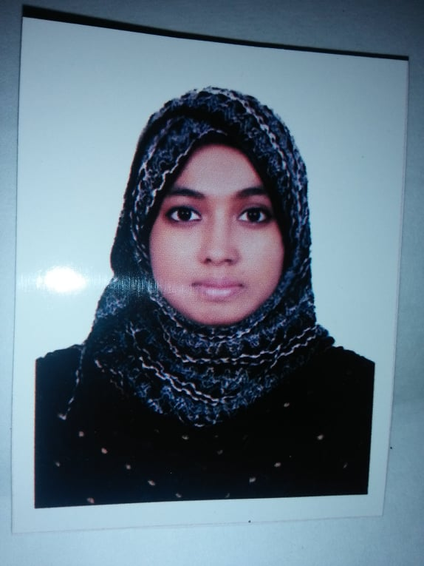
Milling Address
Mobile : +8801928344042
E-mail : raisarahmanraisarahman@gmail.com

CAREER OBJECTIVE:

To pursue a high challenging and creative career, where I can apply my existing knowledge and creativity, acquired new skills and contribute effectively to the organization.

PERSONAL INFORMATION:

Father’s Name :Md.Abul kashem
Mother’s Name : Mrs. asma akther

Present Address : House#15, mirpur,
Post & Police Station: Mirpur 10(1216). Dist: Dhaka-1216.

Permanent Address : House#15, mirpur,
Post & Police Station: Mirpur 10(1216). Dist: Dhaka-1216.
Date of birth : 27-12-1999
Sex : Female.
Marital Status : Unmarried.
Nationality : Bangladeshi (By Birth).
Religion : Muslim (Shunni).
Height : 5ft.

Blood Group : o+
EDUCATON & QUALIFICATION:

B.Sc. in Electronics and Communication Engineering
Result: Continuing in Study.
Institute of Science & Technology (IST).

Higher Secondary School Certificate, 2018
Result : GPA- 4.56 (out of 5.00)
Group : Science.
Institute : Shaheed police smrity college,Dhaka
Board : Dhaka

Secondary School Certificate Examination, 2015
Result : GPA- 4.56 (out of 5.00)
Group : Science.
Institute : B.N School
Board : Dhaka

SKILLS:

- Excellent communication skills as well as approachable nature.
- Good at listening to people.
- Volunteering different types of events or shows.
- Energetic and ready to learn new things by doing.
- In ambitious and target oriented.
- Belief in creativity and multi-dimension.

COMPUTER LITERACY, LANGUAGE & SOFTWARE PROFICIENCY:

- Programming Language: C, C++
- Other Software: Microsoft Word, Power Point.
- Engineering software: Arduino Software, Proteus.
- Language: Bangla (native language), English (proficient in both writing and speaking).

EXTRA CIRCULAR ACTIVITIES:

- Member of “Electronics,Communication & Robotics Club(ECRC).(2016 - ).
- Member of “Programming Club of IST (PCIST). (2016- ).

INTEREST:

Traveling, Social works, Playing football & Cricket, Watching Movie, Knowing people and Reading newspapers.

DICLARATION:

I certify that all information state in this resume is true and complete to the best of my knowledge. I authorized the receiver of this CV to verify the information provided in this resume.

……………………………………..
Raisa rahman

Date: -2020

