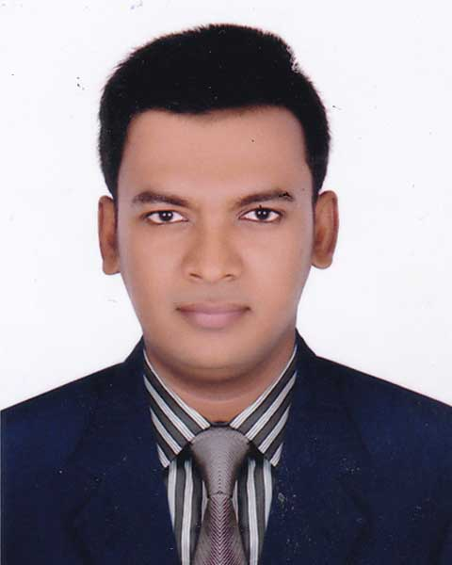

Curriculum Vitae
Of
ANIK GHOSH
C/O Shivu Ghosh
BBA
Private University
Dhaka, Bangladesh
Contact No: 01821888977
Gmail:anik48e@gmail.com
Md.AbulKalam
Mobile: 01737918302
Email:abulkalam100mcj@gmail.com

Career Objective

It is my early dream to be hold a prospective position in any National, multi-national or well reputed organization for the betterment of human life and nation to enjoy challenging career, achievement in profession, and scope of creativity with freedom to work. I believe in hard-work, honesty, sincerity, responsibility, and patience to reach a man’s goal. I also believe in the acquisition of knowledge before applying it.

Educational Qulification

BBA
Institute : World University of Bangladesh.
Result : CGPA-3.10
University : Private University
Subject : Accounting
Passing Year : 2018

Higher Secondary Certificate (H.S.C)

Institute : Udyan Uchcha Madhyamik Bidyalaya.
Result : GPA- 4.20
Board : Dhaka
Group : Business Studies
Passing Year : 2011

Secondary Certificate (S.S.C)

Institute : Dhaka Collegiate School.
Result : GPA-4.31
Board : Dhaka
Group : Business Studies
Passing Year : 2009

Computer Skills

- Ms- word- with English Typing, Ms- Excel, Ms- PowerPoint, E-mail & Internet Browsing.
Hobbies and Interests

- Reading Books
- Travelling
- Watching Movies
- Listening Song
- Playing Cricket

Personal Details

Father’s Name : Shivu Ghosh
Mother’s Name : Anjhona Ghosh
Present Address : 57, Radhika Mahon Basak Lane,
Kotwali, Dhaka-1100.
Permanent Address : 57, Radhika Mahon Basak Lane,
Kotwali, Dhaka-1100.
Date Of Birth : 05/01/1994
Height : 5 Feet 3 Inch
Religion : Hindu
Marital Status : Unmarried
Nationality : Bangladeshi (By Birth)
Gender : Male

Diclaration

I hereby consciously ascertain that all the particulars mentioned above are true. I myself will be liable for any misinformation mentioned herewith.
Reference

Dr. Selim Ahmed PHD

Head, World School of Business
World University of Bangladesh.
Mobile : 01813803448
Email:selim.ahmed@business.wub.edu.bd

Dr. Shishir Ghosh

Resident Dental Surgeon
Bangabandhu Sheikh Mujib Medical University.
Mobile : 01913017946, 01843444462
Email:shishirg.unimed@gmail.com

Date: Anik Ghosh

