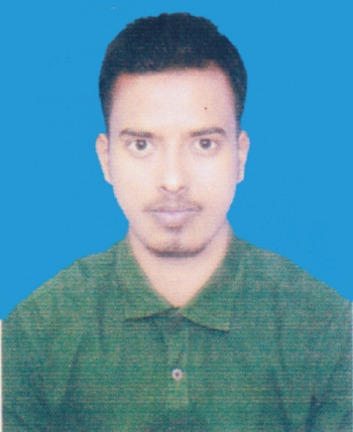
CURRICULUM VIATE
OF
AKIKUL ISLAM
Mailing Address:
House: 25, Road:01, Block: B, Section: 13,
Mirpur, Kafrul, Dhaka- 1216
Cell: 01754-926093
E-mail: shazedulalam89@gmail.com

Objective | To work in responsible position where I could use my Interpersonal skills. Creativity and above all my learning experience in order to develop my career as well as to contribute in your sector.

Educational Qualification

Higher Secondary Certificate | Institute : Susang Govt. Mohabiddalaya, Netrokona  Board : Dhaka  Result/GPA : 3.83  Group : Business Studies  Passing year : 2018

Secondary School Certificate | Institute : Guzirkona High School, Netrokona  Board : Dhaka  Result/GPA : 3.72  Group : Business Studies  Passing year : 2016

Training Skills/  Technical Training | 1. 3 month Web Design Course in BCE-IT at mirpur-10, Dhaka.

Experience | - 03 months Event (Market Innovation International Ltd.) Experience as a Executive at Rajshahi.

Language | Excellent in speaking and writing Bangla (Mother Language)  Fluent in Reading, Writing, listening and speaking English.

Computer Skills | Application Software, Strong Command over Microsoft office word, Excel & Internet Browsing.

Personal Details | Name : Akikul Islam  Father's Name : Hobi Mia  Mother's Name : Farida Khatun  Date of Birth : 26/12/2000  Nationality : Bangladeshi  Religion : Islam (Sunni)  Sex : Male  Marital Status : Unmarried  Blood Group : O+

Permanent Address | Vill: Sreeramkila, P.O: Guzirkuna,  P.S: Durgapur, Dist: Netrokona

Reference

Md. Mahmudul Hasan Mamun
Lecturer of Managment
Department of BBA
Institute of Science Trade and Technology
Mirpur-13, Dhaka.
Cell: 01921-234397

Declaration | I here by declare that the above statement are correct and complete to the best of my knowledge.

Signature :

Date:

