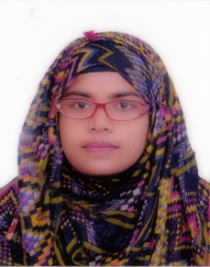
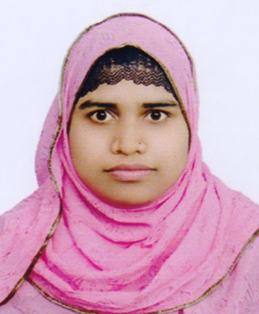
Curriculum Vitae Of

Fahema Akhter
Cell: 01767-737603
E-mail: fahimaakther01923@gmail.com

Career Objective:

I want to apply all my theoretical and practical knowledge and expericnce that I have gained to uphold the institution where I will work. I will try my best to perform my duty honestly, sincerely and effectively.

Education:

2018 BSC (Engineering)
From: Sylhet International University, Sylhet.
Dept. of CSE.
CGPA: 3.36 out of 4

2013 : Higher Secondary Certificate (H.S.C)
From : Sunamganj Govt. College
Group: Science
G.P.A : 4.00 out of 5.00

2011 Secondary School Certificate (S.S.C)
From-: Govt. S.C Girl’s High School, Sunamganj
Group: Science
G.P.A : 4.63 out of 5.00

Experience :
- English Teacher of Bidyaniketon,Sylhet.(Running)
- Computer Operator at Ambition Coaching Home, Sylhet.
Others:
- Have a good knowledge in Microsoft Word, Excel, PowerPoint,PHP,HTML,
E-Commerce.
- Have a good knowledge of using Internet & E-mail.
- Good representation ability
- Enthusiastic in challenging working field.
- Good writing and oral communication ability in English and Bengali.
- A Good team worker and can organize a team very well (class monitor, program organizer).
- A Quick learner and can adjust myself to changes and new situations.

Personal Information:

Applicants Name : Fahema Akhter
Fathers Name : Md. Main Uddin
Nationality : Bangladeshi
Marital Status : Unmarried
Religion : Islam
Present Add. : House No: 358, Uttor Bagbari, Sunumia Complex,
Modina Market, Sylhet.
Permanent Add. : Vill: Khaerdir Char (Kaji Bari) , P.O/P.S: Dharmapasha
Dist: Sunamganj.

References:
2. Abdul Awal Ansary
Ass.t Professor
Dept. of CSE
SIU,Sylhet.
Mobile: 01710445033
- Khaled Hussain
Head
Dept. of CSE
SIU, Sylhet.
Mobile: 01712219040

----------------------
Date & Signature

