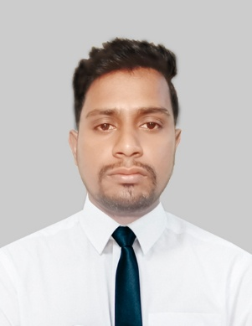
MD. Sahajan Ali
House-51, Road-17,Nikunja-2,Khilkhet, Dhaka-1229
Cell: 01316436030
E-mail: skhanali12021993@gmail.com

Career Objective

To build up career in a prominent and progressive organization which can take full advantages of my knowledge, skills and thus offers the opportunity for career growth through proven performance. To establish myself as a professional expert provide my academic, practical, administrative and managerial Knowledge according to my position.
Committed to fulfill duties and responsibilities with self-motivation, innovation, conferring quick decision, hard work and enthusiastic and reach my organization at peak.
Strengths

I am an energetic, dynamic and of pleasant personality, having ability, responsibility and skill to work on own initiative in all atmosphere.

Academic Qualification

National University of Bangladesh
Programme : Political Science
Result : 3.18 GPA on the scale of 4.00
Institute :Rajshahi College
Shaheb Bazar, Rajshahi
Passing year : 2017

Higher Secondary School Certificate
Group : Humanities
Result : 4.80
Institute : Varendra College
Miapara, Rajshahi-6100
Passing year : 2012
Board : Rajshahi.

Secondary School Certificate
Group : Humanities
Result : 3.94
Institute : Barakhol High School
Mirat, Raninagor, Naogaon
Passing year : 2010
Board : Rajshahi

Computer Literacy

- Microsoft Office Program (Word, Excel, Power Point)
- Extra activates (Net Browsing, Reading, Blogging, fusion)

Language Proficiency

Basic speaking and writing Bengali & English.

Distinction of My self

- Able to work under challenging environment.
- Energetic and result-oriented professionals.
- Willing to work in team.
- Organized and self-motivated.
- Good interpersonal communication skills.
- Interest in innovative ideas, global Issues.
- Information technology concentration.
Personal Information

Father’s Name : MD. Azahar Ali
Mother’s Name : MST. Shohejn Bibi
Date of Birth : 12-02-1993
Gender : Male
Marital Status : Unmarried
Nationality : Bangladeshi
Religion : Islam
Permanent Address : Vill: Barakhol Post: Mirat, Thana: Raninagor
Dis: Naogaon
Current Location : Dhaka

References

MD. Shakilur Rahman
UX/UI Designer
SAJ Architects
Cell: 01521-475317

I hereby declare that the above statements are correct and complete to the best of my knowledge.

-----------------------------
Sahajan Ali

