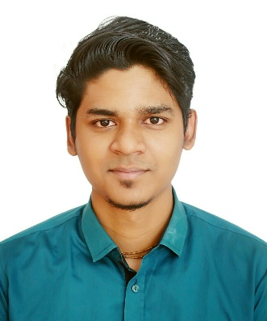
Resume Of
Suvro Roy

Shopnil 48

Ramer Dighir par, Sylhet-3100

Mobile: +880 1758 363 729

E-mail: suvroroy724@gmail.com

Job Objective: Want to be attaching with some creative works. Apply my theoretical and practical academic knowledge to build up my career with highest sincerity and to concentrate on every step of benefit for the organization.

Educational Qualification:

BBA (Hon’s) in Finance, (2018)
Institute- Sylhet International University,Sylhet.
Result- 3.32 (on a scale of 4)

Higher Secondary Certificate (2013)
Institute- Madan Mohan College, Sylhet.
Board- Sylhet
Group- Science
Result- 3.10 (on a scale of 5)
Secondary School Certificate (2011)
Institute- Police Line High School, Sylhet.
Board- Sylhet
Group- Science
Result- 3.81 (on a scale of 5)

Lingual Capabilities:
Bengali (Mother tongue)
English
Highlights of Qualifications:
- Excellent leadership, management and motivational skills
- Effective interpersonal & excellent communication skills
- Strong Self-confidence, flexibility and sense of humor.
- Ability to maintain confidentiality of work related information and materials.
- Strong ability to work effectively with co-workers as a part of team.
- Substantial organizational and problem-solving skills.

Work Experience:
Territory Sales Manager at Walton Digi-Tech Industries Ltd.
Personal Background:
Father’s Name- Shoshanko Shakor Roy
Mother’s Name- Dipa Roy
Date of Birth- 01/Jan/1995
Marital Status- Unmarried
Nationality- Bangladeshi
Blood Group- B Positive
Religion- Hinduism
Permanent Address-
Vill. Noyabarnka
Upazilla. Bisshembherpur
Dist : Sunamgonj
Computer Efficiency-
Operating Software, MS-Word, MS-PowerPoint, Email and Surfing.

Reference
- Supan Kanti Roy

Territory Officer

Banglalink Digital Communication Ltd.
E-mail. : supan.roy@banglalink.net
Contact no : 01962424778

- Pronab kumer saha
sr. lecturer
department of Business Administration
sylhet international university
E-mail. : pronab.saha08@gmail.com
Contact no : 01914706933

I certify that above mentioned information is correct to the best of my knowledge.

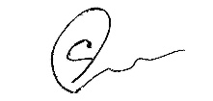
Signature
………………………………………………………
Suvro Roy

