Curriculum Vitae
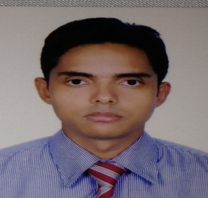
Zibon Lal Dey
Kishmoth Maizbhag
Hetimgonj, Golapgonj
Sylhet-3100
Cell-01778260720
Email- zibon_10@yahoo.com

Career Objective :

To work with a leading organization where to keep using my analytical thinking to the best of my ability combined with perseverance, so as to contribute to company’s growth and goal, as well as to attain my professional goal.
Personal Profile:
Enthusiastic, reliable, multilingual and friendly individual who works hard to achieve potentials. Adaptable, committed and organized with a lot of operational activities. Good communication skills and ability to work under pressure. A quick learner who is always seeking learning opportunities. Works well as a team member and as well as individually.
Experience:
- I Had worked as an Office Administrative in to the Fusion International Ltd. Shobanighat, Sylhet from jan-2005 to Feb 2007.
- I had worked as an Executive, Impaired Assets Management in BRAC Bank Ltd, Zindabazar Branch, Sylhet, during the period of March 2007 to October 2009.
- I have been working as an Accounts Manager, in KTR Corporation (Transport & Housing business), Chowhatta Point, Sylhet, from Oct. 2015 to till date.

Major Responsibility:
- Revenue and expenditure variance analysis
- Cash forecasting
- Accounts payable/receivable
- Establish and maintain files/records to document transactions.
- Cash receipt, Check runs
- Monthly report on activity to upper management
- Update accounting records with payments/balances/customer information
- Provide recommendations

Academic Profile:
M Sc. in Chemistry in 2003 (exam was held in 2005)
Diploma in Accounting and Business under ACCA in 2013

Technical Skills:
MS- OFFICE, Accounting software - Sage
IELTS: Overall band score – 6.5 (Exam Date 21.01.2017)
DOB: 22nd June 1980
Father’s Name: Joshoda Ronjon Dey
Mother’s Name: Late Protima Dey
References:

Royal Kumar Adithya Adv. Ashok Kumar Deb
Lecturer M.S.S, L.L.B
Israb Ali High school & College Bar Hall No-5,
Kuchai, South Surma, Sylhet Judge Court, Sylhet
Cell-008801718267802 Cell- 008801712140910

(Zibon Lal Dey)
Signature

