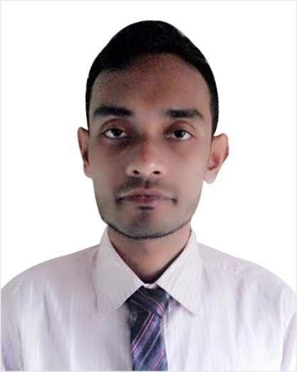

Curriculum Vitae

Of

MD. KUIYUM UDDIN AHMED

Personal Particulars:

Applicant Name : MD. KUIYUM UDDIN AHMED
Father’s Name : MD. MARUF HUSSAIN
Mother’s Name : LATE ABEDA SULTANA
Permanent Address : Provati 57,Pirmoholla, Sylhet
Date of Birth : 20 March, 1993.
Nationality : Bangladeshi (By birth)
Religion : Islam
Marital Status : Single
E-mail Adress : Kaiyumahmed70@gmail.com
Concact no : +8801797056994

Educational Background
Masters of Business Administration (M.B.A)
Major Subject : Management
Graduation Year : 2016
CGPA :3.09
University : National University, Bangladesh.
Institute : Madan Mohan College, Sylhet

Bachelor of Business Administration (B.B.A Honours)
Major Subject : Management
Graduation Year : 2015
CGPA : 2.98
University : National University, Bangladesh.
Institute : Madan Mohan College, Sylhet

Higher Secondary Certificate (H.S.C)
Group : Business Studies
Passing Year : 2011
Board. : Sylhet
GPA : 4.40
Institution : Madan Mohan College, Sylhet

Secondary School Certificate (S.S.C)
Group : Business Studies
Passing Year : 2009
Board. : Sylhet
GPA : 4.38
Institution : The Aided high school, Sylhet

Language Proficiency:.
- Have an excellent command over English
- Good interpersonal Communication skill.

Career Objectives:
To obtain a challenging position in any area of organization that will provide future opportunities for growth and development. Added that to use my skills and experience that I have acquired in my education life and to dedicate my whole effort to achieve the organizational goal.

Key Skills:
- Work with various types of people.
- language : English (good spoken and written command)
- Strong desires for leading an honest life.
- Leadership
- Six months Diploma in Computer.

Interest:
- Participating in social work.
- Traveling
- Listening music.

EXTRACURRICULAR ACTIVITIES :
- Worked as a volunteer,in Vard(2012-2015)
- Got Training as a fire fighter.
- Got training from First Aid.
- Got psycho social training.

Referenc
Kamal Uddin Ahmed
(Advocate judge court,Sylhet)
mobile +8801719230323

Jayanto das(Department head,Management )
Madan mohan college, Sylhet
mobile +8801711325559

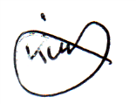

Signature
Date: 27/04/2019

