CURRICULUM VITAE

Dr.TabiyaMahbub  7/4 Monipuripara, Farmgate ,Dhaka- 1215  Opposite to shangshad avenue  01727346220  tabiya.mahbub@gmail.com | 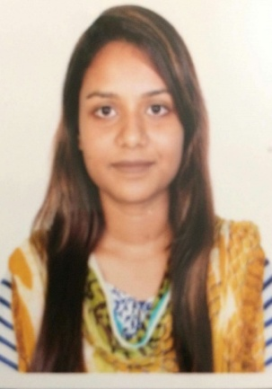
Objectives:
Building up career in a challenging environment as a Teacher, Physician working with humanity, dynamism, creativity, sincerity, skill and performance.

Educational Qualification:

Degree | Institution | Year | Marks/GPA
BDS (Bachelor of Dental Surgery) | Bangladesh Medical and Dental College and Hospital | 2016 | Passed in all subjects in Regular Batch
HSC (Science) | Dhaka City college | 2011 | GPA-5
SSC (Science) | YWCA Higher secondary Girls high school | 2009 | GPA-5

** Currently doing Masters in PUBLIC HEALTH in NORTH SOUTH UNIVERSITY **

Area of Interest:

Teaching, Clinical Work, Patient dealing and consultation, Treatment planning, Orthodontics, Surgery etc.

Internship:

Full one year internship under supervision of Professors in respective department of Bangladesh Medical and Dental College & Hospital, Dhanmondi, Dhaka-1205.

Working Experience:

Honorary medical officer in Shaheed Suhrawardy Medical College and Hospital in Oral and Maxillofacial Surgery Department.

Personal Details:

Name | : | Tabiya Mahbub.
Father’s Name | : | Mahbubur Rahman.
Mother's Name | : | MannujanAra Begum (Housewife).
Date of Birth | : | 13th October 1992.
Nationality | : | Bangladeshi By Birth.
Present Address | : | 7/4 Monipuripara , Farmgate , Dhaka- 1215.
Permanent Address | : | C/O, Mostafizur Rahman 13, Thanapara , Lalmonirhat-5500.
Marital Status | : | Single.
Sex | : | Female.
Religion | : | Islam.
Blood Group | : | O⁺
Contact no. | : | 01727346220 , 9145486.
E-mail | : | tabiya.mahbub@gmail. Com

REFARANCE:

Prof. Dr. MD. Ramjan Hossain.
BDS , PHD ( Japan )
Head of the Dept of Oral Anatomy and Physiology.
Bangladesh Dental College

Dr. RafiqurRahman
Associate Prof. Dept of Prosthodontics.
Bangladesh Dental College, Dhaka.
Mobile: 01791-756200

Dr. KaziShagufaYazdi
Associate Prof.Dept. of Pediatric Dentistry.
Bangladesh Dental College, Dhaka.
Mob: 01711-590465

