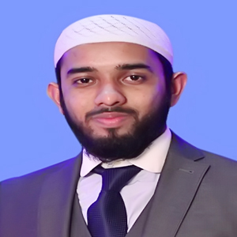
Curriculum Vitae
of
Emad Uddin Muhammad Emdad

Address: Majhar-Monjil,Shevok-42,Raynagar,Sylhet.
Phone: 01674808444
E-mail: emdadmuhammad.bd@gmail.com

Objective:

- To build up myself as a challenging responsible person to utilize my education and other experiences to show my creativity and integrity, at the same time to fulfill the desire to work in a competitive, dynamic and disciplined job environment to enrich professional skills, competency and level of expertise knowledge.

Personal Information:

Father’s Name : Advocate Kutub Uddin Ahmed
Mother’s Name : Sultan Ara Begum
Date of Birth : 30 June, 1994
Nationality : Bangladeshi
Marital Status : Single
Religion : Islam
Blood Group : O+(ve)
Permanent Address : Majhar Monjil, Shevok-42, Raynagar,Sylhet.

Education:

Exam Title | Subject/Major | Institution | Result | Pas.Year | Duration
Masters of Law (LLM) | Law | Leading University, Sylhet | CGPA:3.56  out of 4 | 2017 | 1 Years
Bachelor of Law (LLB) | Law | Leading University, Sylhet | CGPA:3.61  out of 4 | 2016 | 4 Years
Higher Secondary Certificate(H.S.C) | Humanities | Scholarshome | GPA:5  out of 5 | 2012 | 2 years
Secondary School Certificate (S.S.C) | Humanities | Shah Jalal Jamia Islamia School & College | GPA:4.63  out of 5 | 2010 | -

Strength

- To work in team and individually.
- Ability to Good planning and organizing skills.
- Ability to manage multiple tasks in pressurized environments.
- Comprehensive Problem solving ability.
- Capable of working under stress.
- Adept in Research Work.

Other Skills:

- I am a proficient operator of MS-Word, MS-Excel, MS-Power Point. I also have knowledge about internet, E-mailing, and other general use of computer and IT.

Languages:

Bangla : Fluent (Mother tongue)

English : Excellent

Work Experience:

Designation: Apprentice Lawyer
Sylhet Judge`s Court.
Duration: From 01 February, 2017 - Still Continuing
References:

Reference: 01
Dr.Md.Abdul Kahir
Upazilla Livestock Officer (ULO),
Department Of Livestock Services (DLS), MOFL..
Mobile : 01774912177
Phone (Off.) : 01712104254
E-Mail : kahirkb1@gmail.com
Reference: 02
Mr Kalam Ahmad Chowdhury
Deputy Registrar,
Shahjalal University of Science and Technology
Mobile : 01788484648
Phone (Off.) :01848064467
E-Mail :kalamsust@gmail.com

Signature
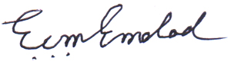
Emad Uddin Muhammad Emdad

