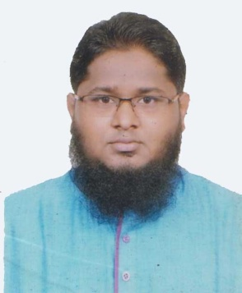
Md. Shohedul Islam

70/2, East Bashaboo, Shabujbag, Dhaka-1214.
Cell- 01820266771


E-mail: faisal4890@gmail.com

Career Objective

To work in a challenging environment that supports my education and talent and opens a new dimension of understanding and learning for affluent career in any reputed organization.

Working Experience

Company Name : Master Textile Mills Ltd.
Head Office,
Noapara Bazar, Tarabo,
Rupgonj, Narayongonj.
Position : Accounts Officer
Duration : 1-04-2015 to 31-05-2018

Job Description
- Develop, update & maintain company accounts .
- Prepare daily report of sales & purchase & maintain daily cash book.
- Complete daily posting of sales, purchase & regular transaction.
- Prepare report of party ledger, cash ledger, profit & loss a/c, as per management requirement

Academic Standing
2010 - 2014 Bachelor of Arts (BA)
Bangladesh Islami University
Major in Islamic Studies

2008- Higher Secondary Certificate,
Business Studies Group
Kadamtala Purbo Bashaboo High School & College , Dhaka.
2006- Secondary School Certificate,
Business Studies Group
Kadamtala Purbo Bashaboo High School & College, Dhaka.

Personal Qualification
- Punctual, reliable and hard worker individual
- Excellent verbal/written communication skills & effective team player
- Strong time/task management skills and capable of multitasking.
- Able to maintain composure and professionalism under pressure

Language Skill
- Bangla (Mother tongue)
- English (Writing, Reading, Listening, Spoken)

Hobbies & Interests
- Working in new environment and befriending people
- Cricket & Badminton
- Voluntary Activities
- Traveling
- Book reading

IT Skills
- Spread Sheet Analysis
- Operating System: Windows
- Computer trouble shooting both software & hardware.

Personal Information
- Father’s Name: Md. Abu Taher
- Mother’s Name: Jahanara Begum
- Date of Birth: 04thAugust 1990
- Gender: Male.
- Nationality: Bangladeshi.
- Religion: Islam
- Marital status: Married
- Blood Group: A Positive (A⁺)

Reefers
Raf.- 1
Md. Mohiuddin Khan
Manager sales & Support
STM vision InfoTech Ltd.
01718272526
Mohiuddin.tally@gmail.com

mo
Raf.- 2
Md. Abul Kalam Azed (Tushar)
Assistant Manager (Sales & Accounts)
The Alpha Engineering
01671968867
Tushar0989@gmail.com

\

Signature

