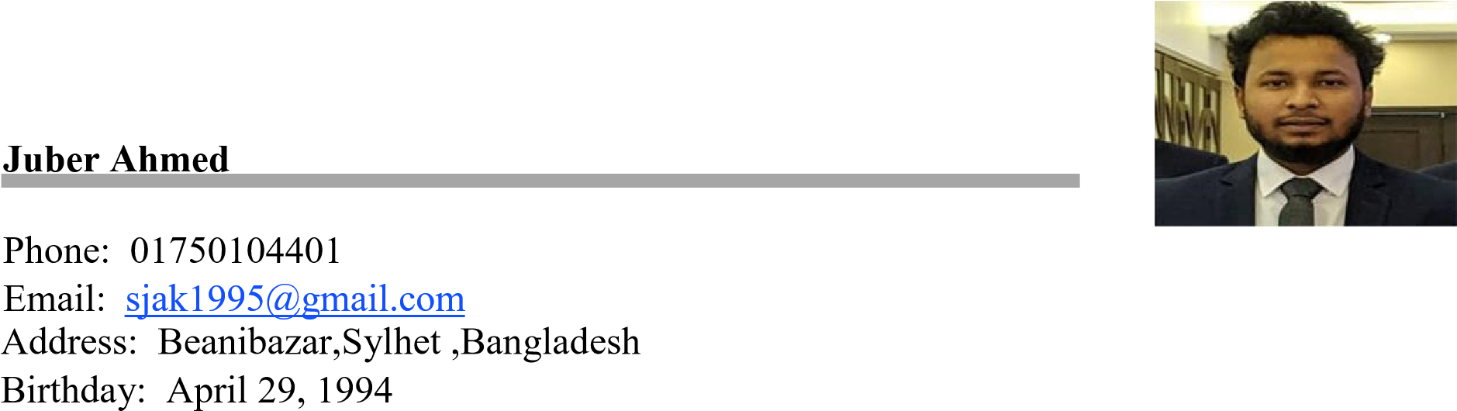

CAREER OBJECTIVE
Seeking a challenging career with a progressive organization that provides an opportunity to capitalize my technical skills & abilities in the field of information technology (IT).

TECHNICAL SKILLS
Language : c , c++, JAVA, PHP, HTML, CSS, Bootstrap
Platform : Android Studio , Microsoft Office, Mat lab, Type Master (55 – 79 wpm)
Android Project : Mess Management, Stay Attached(GPS Phone Tracking System)
Teaching : Delivering ICT Lecture

PERSONAL SKILLS
- Excellent written and verbal communication skills
- Highly organized and efficient
- Ability to work independently or as part of a team
- Proven leadership skills and ability to motivate

EDUCATION Bachelor of Computer Science & Engineering (2014 – 2018)
C.G.P.A : 3.58 out of scale 4
Leading University Sylhet, Bangladesh

ACHIEVEMENTS/RESPONSIBILITIES
- Idea Hack 2018, A hackathon Program(Participant)
- Leading University Computer Club(Ex Member)

REFERENCES:
Rumel M S Pir
Head
Department of EEE
Leading University , Sylhet Bangladesh
Contact No : +8801758228736

