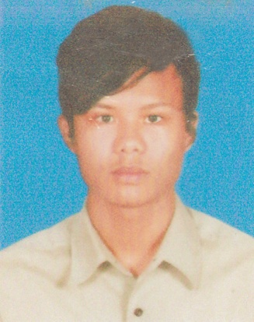
Resume
Resume

of
Shadin Sangma
Contract: +88 01875422396

Career Objective:

To develop my career with the virtues of self motivation, Hard-working and honesty in accordance with the organization development. To work in a dynamic, intensive environment, where the creativity and interest can be found to develop the skills as well as the career with a strong emphasis on sustained growth and development.

Academic Records:

- Higher Secondary Certificate (H.S.C)

- Institute Name : Gulshan Public School & College
- Group : Humanities
- Board : Dhaka
- Passing Year : Running

- Secondary School Certificate (S.S.C)
- Institute Name : Beleatet Hossain Adarsha High School
- Group : Business Studies
- Board : Dhaka
- GPA : 3.50 out of 5.00
- Passing Year : 2014

Language Proficiency:

- English : Reading, Writing and speaking ability.
- Bengali : Mother tongue.

Working Experience:

Name of organization : Daraz Online Marketing
Position : Operator
Duration : 3 years

Name of organization : Data Entry
Position : Operator
Duration : 2 years

Name of organization : Xian Ju Chinese Restaurant
Position : Service
Duration : 1 years

Special Characteristics:

Possess good communication skills and love to work with people.
Have strong determination and devotion to work.
Love to engage with challenging activities.

Personal Details:
- Name : Shadin Sangma
- Father’s Name : Mithun Dibra
- Mother’s Name : Bimolis Sangma
* Present Address : House:442, Road-23, Block-D, Shajalal
Upo- Shahar,Sylhet-3100
* Permanent Address : Vill:Chorbangalia P.O: Haluaghat,
P.S Haluaghat,, District: Mymensingh
- Date of Birth : 26 March, 1997
- Gender : Male
- Marital Status : Unmarried
- Religion : Christian
- Nationality : Bangladeshi (By birth)
- Height : 5'-7"
- Weight : 65 Kg
Hobbies:

Traveling, Reading Newspaper
Reading books, Watching Movies & Meeting new people & new location.

Computer Skill:

Ms word, Power Point, Excel, Net Browsing. Typing Speed- 40%

Capability:

- Ability to work under pressure.
- Decision making
- Time Management
- Self-motivation
- Creativity

Declaration:

I am the undersigned hereby declare that I will be responsible for any wrong information provided here.

Date: ……………….. …..........…………………….
(Shadin Sangma)

