CURRICULUM VITAE

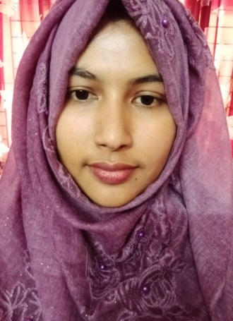

NAME: RUMKY AKTER

CONTACT INFORMATION

Current Address: H-79,Road-12,sector-13, Dhaka- 12
Contact Number: 01838607251
Email Address: rumuchi00@gmail.com
CAREER OBJECTIVE
Secure a responsibble career oppurtunity to fully utilize my training and skills, while making a significant contribution to the succes of the company.
PERSONAL INFORMATION
Father’s Name : Shahid Miah
Mother’s Name : Bakul Begum
Date of Birth : 01/01/2000
Nationality : Bangladeshi
Sex : Female
Religion : Islam
Marital Status : Unmarried
Upazilla : Brahmanbaria Sadar
District : Brahmanbaria
EDUCATION QUALIFICATIONS
 | Certificate | Board | Institution | Passing year | GPA
01. | Secondary School Certificate | Comilla | Sabera Sobhan Govt. Girls High School | 2016 | 4.00
02. | Higher Secondary Certificate | Comilla | Brahmanbaria Govt. Women college | 2018 | 3.31
03. | BSC in Fashion deisgn and technology |  | Uttara University of Bangladesh | 2019 | (current)

STRENGTHS/TRAITS & SKILLS
- High degree of initiative.
- Strong presentation skills.
- Able to work within tight schedules.
- Good writing skills.
- Good command in both oral and written English.

COMPUTER SKILLS
      - Efficient in MS Word, MS Powerpoint and MS Excel.
      - Efficient in Statistical Package for Social Sciences (SPSS)

INTERESTS/ HOBBIES
- Reading Books
- Painting
- Writing Articles
- Browsing net
- Playing game
- Movies
- Crafting

