Curriculum Vita of Laboni Akhter.
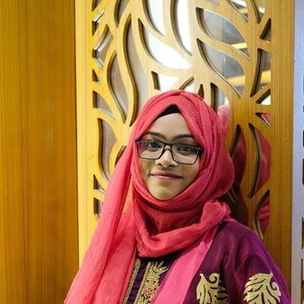
Laboni Akhter.

House No- , 16, Road No- 02 .
Kaderabad housing,mohammadpur
Dhaka, Bangladesh
Mobile: +8801686622039
E-mail: laboni.akhter2016@gmail.com

Posted For: - To pursue a challenging position with honesty & better work ability in this company/Organization.

Career Object: - I would like to work in career based reputed organization, where I can apply my knowledge to pursue a professional career and provides an excellent job environment for career growth. I’m hard working self-motivated enthusiastic individual as well as able to carry on target-oriented job.

Education Qualification
Hon’s | - Institution- Eastern University, Dhanmondi 5, Dhaka.  - Program- LL.B(Hons)  - Result- 3.53  - Year- 2019  - ID- 153100044
H.S.C | - Institution- Dohar Nawabgonj college  - Group- Science.  - Result- 4.20  - Passing Year- 2014  - Board- Dhaka
S.S.C | - Institution- Kolakopa k.p High school.  - Group- Science.  - Passing Year- 2012  - Result- 4.06  - Board- Dhaka.

Computer Literacy
MS Word, M S PowerPoint, Internet Browsing, E-mail and others.
Language Proficiency
Best communication skill both in Bengali and English.
Others Skills
Good in drafting, Good in presentation, Submission & speak in public.
Comfort in doing group work, Able to work under pressure.
Personal Profile
- Name : Laboni Akhter
- Father’s Name : Lablu Sheikh.
- Mother’s Name : Asma Begum.
- Permanent Address :
Village- Soyedpur ,purbopara
Post- Mohabbatpur
Upazilla- Nawabgonj 1320
District- Dhaka
- Date Of Barth : 4th July ,1997
- NID Number : 7351638502
- Nationality : Bangladeshi by birth.
- Home District : Dhaka
- Marital Status : Married.
- Religion : Islam (Sunni)
- Blood group : B+

Reference
Name- Md Saidul Islam
Designation-Assistant Professor, faculty of Law
Organization-Eastern University
House- 26, Dhanmondi 5
Dhaka .
Phone- 0976031-3,Ext 505
E-mail- saidul.islam@easternuni.edu.bd

Laboni Akhter.

