- Curriculum Vitae
of
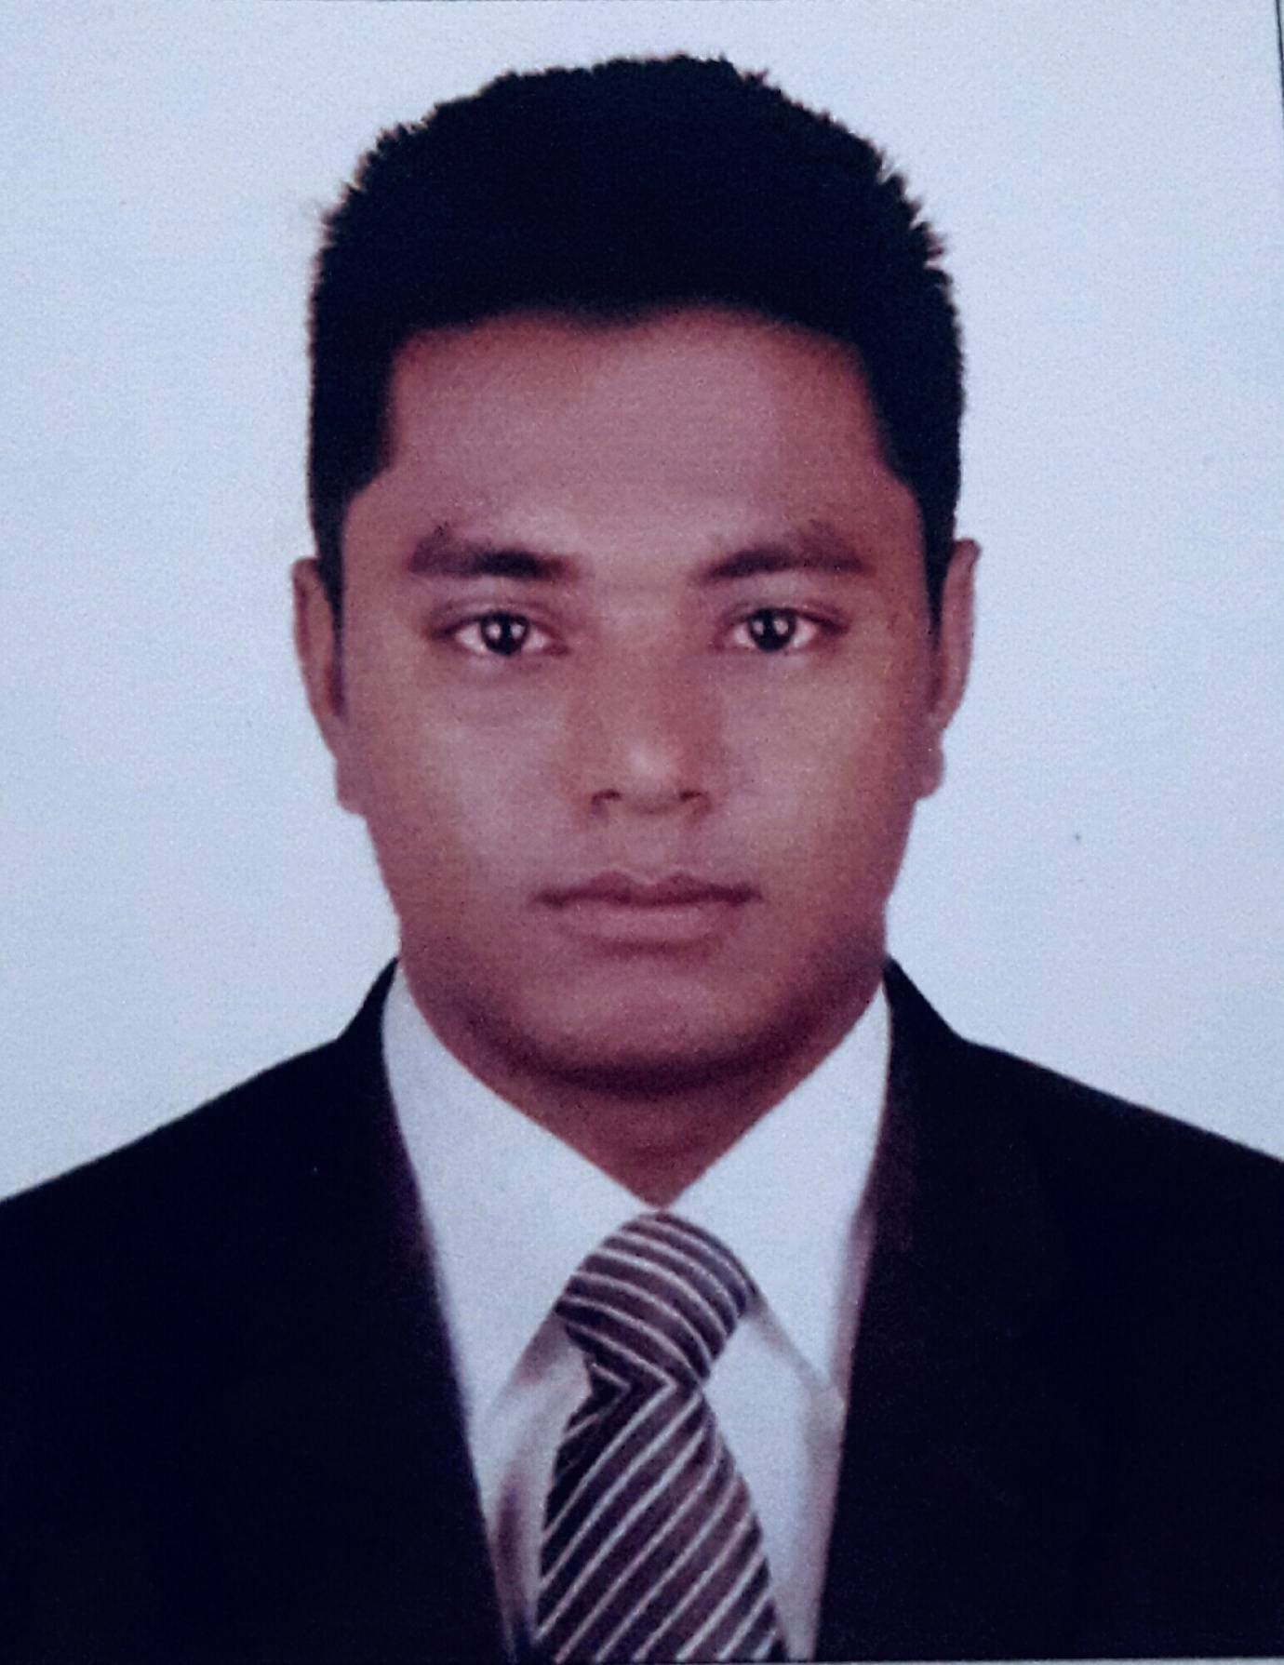
- Parvez Ahmed
Contact: +8801779-797333
E-mail: parvezmou03@gmail.com

Career Objective
To work in an organization where self-motivation communication skill and creativity gets the optimum priority and my knowledge will be enhanced in various fields with the great enthusiasm.

PERSONAL INFORMATION:
Name : Parvez Ahmed
Father’s Name : Nurul Islam
Mother’s Name : Fatema Begum
Date of Birth : 05-01-1992
Nationality : Bangladeshi.
Religion : Islam
Marital Status : Unmarred
Sex : Male
Blood Group : A+
Contact No : 01779-797333
Permanent Address : Vill: Bijoyparua, P.O: Chorar Bazar,
P.S: Companigonj, Dist: Sylhet.
Present Address : Udoyon51,Ilaskhandi road,sylhet
Educational Qualification:
Secondary School Certificate (S.S.C)
Name of Institute : Fatehpur M.H High School.
Group : Business Studies
Result : 3.68
Passing year : 2008
Board : Dhaka

Higher Secondary Certificate (H.S.C)
Name of Institute : Uttara Anawara Model Degree College.
Group : Business
Result : 2.80
Passing year : 2011
Board : Dhaka

Language Skills: Both Bangla & English

Computer Skills :
Microsoft Office Application & Internet Browsing.

Working Experience:I am served as a Field supervisor in BashundaraGroup. Since 11 August 2012 to 31 August 2013.
Reference:
- Monsur Ali
Head master.
Ronikhai H.R.C High School. Sylhet.
Companigonj, Sylhet.
Cell No: +8801731-306624

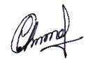
Signature
Date: 27-03-2020
................................
(Parvez Ahmed)

