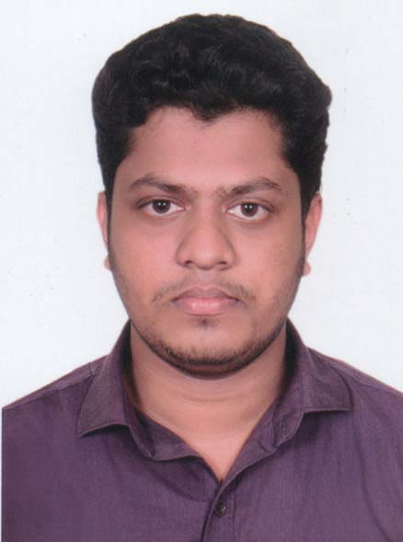
Curriculam Vitae

DR. MD SAKHAWAT HOSSAIN
BDS (CU), Dental Surgeon
Chattogram Medical College, Chattogram.
BMDC Registration no:9258
Contact:
01628270275
01878169412

Email: sunnysakhawat7@gmail.com

Career Objectives
To be dynamic professional having the capability of facing the challenging situation and utilize my educational qualifications and gain utmost competence in the field of health sector through enthusiasm, hard work, ethics, sincerity and brilliance. Moreover serve for the welfare of the society through the assigned responsibility.

Personal Information:

Name : Md. Sakhawat Hossain
Father’s Name : Md. Abul Hossain
Mother’s Name : Salina Akter
Gender : Male
Date of Birth : 11th October, 1993
Religion : Islam
Marital Status : Single
National ID NO : 19931526105000117
Present Address : Flat # 18-B-2, Stuff Quater Chattogram Medical Hospital, Panchlaish,
Chattogram- 4000.
Permanent Address : Village- Iswar Khine, P.O- Dhalghat, P.S- Patiya, Dist- Chattogram.
Academic Qualifications:-
Examination | Concentration | Name of Institution | Passing Year | Result
BDS | Dental Surgery | Chattogram Medical College  Dental Unit | 2017 | Passed
HSC | Science | Patiya Govt. College | 2011 | GPA 5.00
SSC | Science | Abdus Sobhan Rahat Ali High School | 2009 | GPA 5.00

Working Experiences:
- One year of rotatory internship in Chattogram Medical College Hospital.
- Working as a Consulting Dental Surgeon at Dr. Fourkans Dental Clinic from 06th September 2018 to till now.

Training & Conference:
- Attended ‘1st National Conference Chittagong 2017 update on Management of Oral Cancer Patients in Bangladesh.
- Attended ‘International Dental Conference & Trade Fair 2019.
- English Language Training (ELT) at Wenlyn Global Group course completed.

Responsibilities Handled as Dental surgeon:
-Diagnosing the diseases as per symptom
-Performing basic Endodontic and Restorative Treatment and basic Oral & Maxillofacial
Surgery.
-Assisting the senior Doctors for patient check up
-Observing them while performing their duties
-Assisting them to surgery
-Checking the investigation reports of the patient
-Checking Follow up from the nurses about regular treatment and dose of the patients
-In case of emergencyperforming basic treatment

Key Skills:
-Self Motivated
-Strong Concentration & Patience
-Punctual & Disciplined
-Good Verbal & written communication skills in both Bangla & English
-Good Command over handling medical equipments
-Well versed with the basic use of computer

Interests:
- Travelling
- Voluntary activities
- Playing such as Chess, Cricket etc.

References:
- Dr. Md. Kamal Uddin
BDS (CU), BCS (Health)
Assistant Professor, Department of Dental Public Health Department.
Chattogram Medical College Hospital, Chattogram.
Cell: 01817710716
E-mail: dkuddin@hotmail.com
- Dr. Md. Fourkan Uddin Chowdhury
BDS (DU), BCS (Health)
Dental Surgeon,
Chattogram Medical College Hospital, Chattogram.
Cell: 01819396106

