Biplob Deb Nath

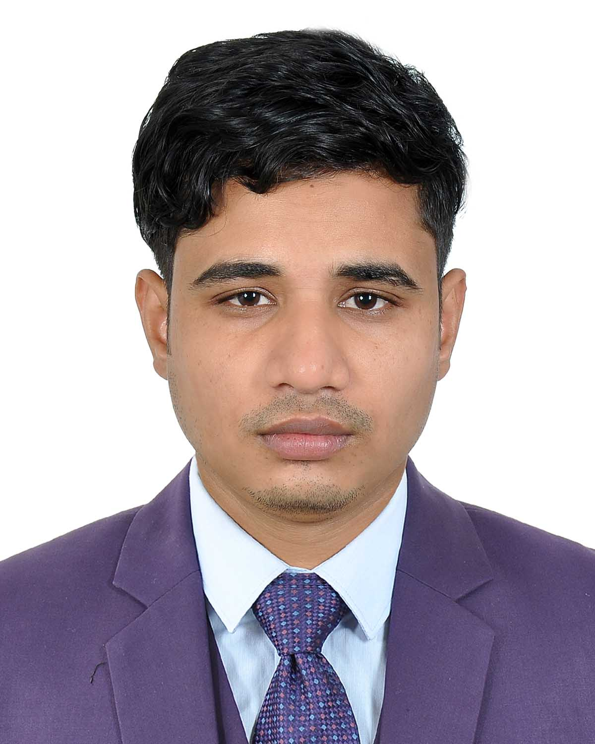

E-mail: biplobnath.bd@gmail.com
Mobile No – 01721680522, 01641214676

Profile:
To serve the people in a suitable environment and to join a position in which I can dedicate potential, academic knowledge and skill I have ever achieved. Always committed and enthusiastic as per my knowledge best and also have a strong interest to work for people by health care service.
Career summary:
To follow a challenging career where would be adequate scope of enhancing my knowledge and developing myself as innovative and positive approach to challenges for earlier establishment.
Academic Qualification:

Course:
- Masters of Social Science (M.S.S):
Subject: Sociology
Session: 2013-2014
Result:2.89
Institute: M.C College
University: National University
- Bachelor of Social Science(B.S.S):
Subject:Sociology
Session: 2009-2010
Result:2.72
Institute:M.C College
University:National University
- Higher Secondary Certificate (H.S.C):
Group: Science
Passing Year: 2009
Session:2007-2008
Result:3.80
College:Sylhet Govt College,Sylhet
Board: Sylhet
- Secondary School Certificate(S.S.C):
Group: Science
Passing Year: 2007
Session:2005-2006
Result:4.13
School:Jobed Ali Secondary School
Board: Sylhet

Total Year of Experience: 7.5 Year
1. Program Assistant (01 April 2021 – 31 March 2022)
Icddrb, ACTB,IDD

Duties/Responsibilities:
- Facilitate the learning session with the FAs every day to build up their knowledge & capacity.
- Observe, assist and provide feedback the FAs for screening out & presumptive finding out.
- Checking the evaluation sheet of the patient and assist presumptive to ensure test advised by Doctors.
- Coordination and liaison with Superintendent, Head of the department, RP, Consultants, indoor & outdoor doctors to build up effective relationship and smooth running our activity.
- Regular visit and communication with DOTS centers, TDC, Facility Lab, Gen Xpertcenter, RTRL, medical college lab, partner organization and other stake holder to ensure test and patient refer.
- Collect test result of Presumptive, refer them respective doctors to diagnosis, preserve relative document, send patient to DOTS center for treatment, collect TR number.
- Maintain a presumptive register for both adult and childhood TB, contact with regular basis with them and ensure reinvestigation where needed.
- Visit Facility Doctors, other hospital & clinic GP doctors to collect information and upload doctor’s information by Docinfo.
- Visit positive patient household, conduct contact investigation for DR TB and DS TB and submit report.
- Maintain documentation such as presumptive register, IMCI register, EPTB information,
- Produce daily, weekly and need based report and submit thorough proper channel.
- Any other activity as per the instruction of Supervisor.

2. Program Organizar(20October 2016 – 31Dec 2020)

HEED Bangladesh(National Tuberculosis Control Program, GFATM)
Duties/Responsibilities:
- Organize and Attend the Different Type of Health Related Meeting&Seminar With The Attending Of Civil Surgeon,UH&FPO,RMO,Medical Officer,Village Doctor& Other Health Related Person
- Trained theOpinion Leader, Tea & Rubber Garden Worker, Village Doctor, Community Volunteer, And Other People about Health, Hygiene& Different Air born Disease Specially TB.
- Monitoring & Supervise the Upozilla Level TB Control Program Staff work.
- Always Provide Technical Support toThe TB Control Assistant.
- Prepare Monthly Quarterly& Yearly Report.
- Attend the Monthly & Quarterly District Level Meeting.

3.Assistant Manager(15 May 2015- 15 Oct 2016)
Delta Specialized Hospital,Sylhet
Duties/Responsibilities:
- Supervised all clinical operations and schedule staff in clinics.
- Evaluated and determined appropriate clinical policies and procedures.
- Ensured optimal patient results and provided support to all clinic staff.
- Provided efficient and therapeutic care to clinical staff and facilitated healing.
- Analyzed clinic patients and provided efficient patient education.
- Making All staff Duty Schedule
- Organize Weekly Staff Meeting and Giving The instruction.
4. Hospital Manager(10 September 2014- 10May 2015)
Gisela Hospital &Diagnostic Center, Hobigonj (A project of CRUD NGOs)
Duties/Responsibilities
- Organized front office operations according to clinic policies.
- Make Everyday Staff Duty Scheduled.
- Evaluated working of Hospital staff and provided training if required.
- Participated in nursing care and maintained patient health at all times.
- Monitored and tracked medication of patients and maintained equipment.
- Monitored all phone calls and scheduled appointments.
- Assisted to prepare all bills and maintained accuracy in process.
- Developed everyday Patients reports and maintained record.

Language Competency:
- Bangla is native language and has good proficiency in speaking as well writeup.
- English-Fluency in both speaking and writing.
- Ielts Score-6

Computer Skill:
- MSOffice (Word, Excel, Access), Power Point presentation, proficiency in Bangla and English Keyboard. Internet Browsing

Extra Curricular Activities:
- Participated in case study competition.
- Participated in debate competition.
- Participated in organizing college event and seminars.
Personal interests/Hobbies:
- Listening Music
- Communicating with people
- Leadership
- Playing Badminton
- Internet Browsing
Personal Profile:
- Name : Biplob Deb Nath
- Father’s Name : Babul Chandra Nath
- Mother’s Name: Rina Rani Nath
- Date of birth : 21/02/1991
- Permanent Address: Vill-Poschimbond, P.O-Thana Bazar, P.S-Zakigonj,Dist-Sylhet.
- Present Address:Babubol,Road-1 Shaporan,Sylhet
- Nationality : Bangladeshi by birth.
- Blood Group : B+
- Religion : Hindu
- Marital status : Unmarried

References:
(1)
- Name:Dr.Ripa Rani Nath
- Organization:SmillingSunClinic,Sylhet
- Designation:Medical Officer (MBBS)
- Address: Moulvibazar,Sylhet,Bangladesh
- Mobile:01712068845
(2)
- Name:Ashish Kumar Ghosh
- Organization:Icddrb
- Designation: Assistant Program Manager(ACTB)
- Address:Mirjajangal,Sylhet
- Mobile:01712775357

Sincerely yours:

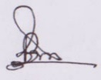
(Biplob Deb Nath)

