JAHANGIR ALAM RUMAN | 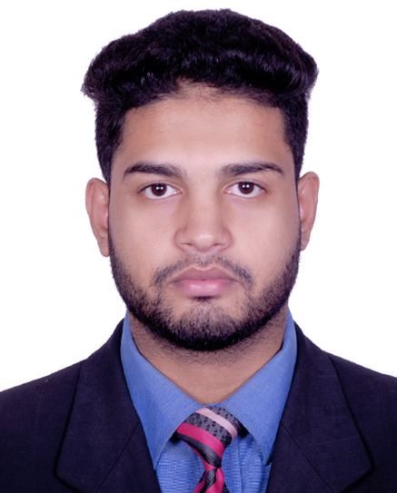
Address: Kazi Illias,Zindabazar, Sylhet.
Mobile No 1: 01715598284
e-mail :Jahangir.ruman@gmail.com,jahangirneubcse@gmail.com

Career Objective:
I always passionate and dedicated to my work and I will keep it ever

Academic Qualification:
Exam Title | Concentration/Major | Institute | Result | Pas.Year | Duration | Achievement
Bachelor of Science (BSc) | Computer Science & Engineering | North East University Bangladesh | CGPA:2.94  out of 4 | 2019 | 4 | -
HSC | Science | Kanaight degree college | CGPA:4  out of 5 | 2013 | 2 | -
SSC | Science | Kanaighat govt high school | CGPA:4.88  out of 5 | 2011 | 5 | -

Career and Application Information:
Looking For | : | mid Level Job
Available For | : | Full Time
Preferred Job Category | : | Engineer/Architect, IT/Telecommunication, Data Entry/Operator
Preferred District | : | Barisal, Chittagong, Comilla, Dhaka, Khulna, Mymensingh, Rangpur, Sylhet

Specialization:
Fields of Specialization | Description
- Software  - Data Entry Operator (Both English & Bengali)  - C++  - Java ME/ J2ME  - PHP  - HTML5 & CSS3  - Hardware  - MS office  - Internet Surfing ability | Problem Solving Experience for 3 years, Solved 400+ Problems on different online and offline judges.  Developed so many softwares both desktop and web based for the academy purpose using the language Java, Python, PHP, HTML, CSS, Bootstrap and so on.  Comfortable with Windows operating system as well as Microsoft Office.  Comfortable with Linux operating system.  Word, Excel, Access, Power point.  .

Extra Curricular Activities:
- Executive Member (2016-2017) Society, NEUB
- Member and Organizer of Robotics at NEUB.

Language Proficiency:
Language | Reading | Writing | Speaking
Bangla | High | High | High
Enaglish | High | High | Medium

Personal Details :
Father's Name | : | Abdul Jabbar
Mother's Name | : | Jaba akther
Date of Birth | : | July 20, 1995
Gender | : | Male
Marital Status | : | Unmarried
Nationality | : | Bangladeshi
National Id No. | : | 19959125903000009
Religion | : | Islam
Permanent Address | : | Kazi Illias,Zindabazar, Sylhet.
Current Location | : | Sylhet

REFERENCES:
Ahsan Habib
Associate Professor
Department of Computer Science and Engineering
North East University Bangladesh
Sylhet, Bangladesh

Al Mehdi Saadat Chowdhury
Assistant Professor and Department head
Department of Computer Science and Engineering
North East University Bangladesh
Sylhet, Bangladesh

I confirm that all information stated in this curriculum vitae is accurate and complete to the best of my knowledge. I also authorize the respective
authority to verify the information provided in this curriculum vitae.
(Jahangir Alam Ruman)

