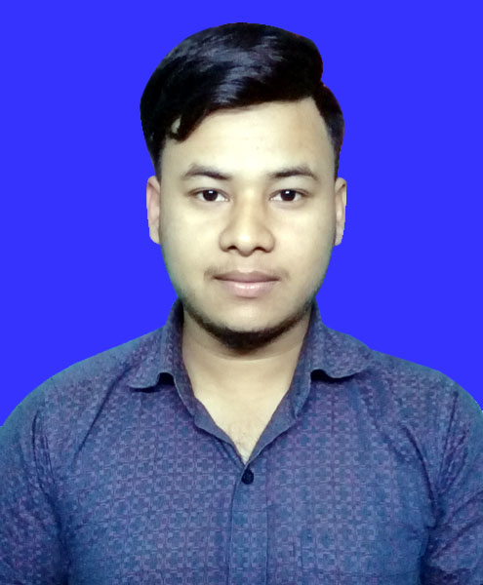
Resume of
Md. Khaja Biswas
Barat, Rajbari-7700, Bangladesh.
Mobile: +8801789164811

Picture

OBJECTIVE
Attainment of maximum value through offering well merited performance and interchanging benefit with the organization. I want to be a perfect working hand of the organization to attain its goal and to build up my career.
EDUCATION
EXAM : Bachelors Of Computer Science & Engineering (CSE)
Institution : Victoria University Of Bangladesh.
Group : Computer Science
Board/ University : Private University
Passing Year : 2019
Result : CGPA-3.04 (Out of 4.00)
EXAM : Higher Secondary School Certificate (H.S.C)
Institution : Goalada Kamrul Islam Degree college
Group : Science
Board : Dhaka
Passing Year : 2014
Result : GPA-3.50 (Out of 5.00)
EXAM : Secondary School Certificate (S.S.C)
Institution : Chowdhury Abdul Hamid Academy
Group : Science
Board : Dhaka
Passing Year : 2012
Result : GPA-2.88 (Out of 5.00)
LANGUAGE
- Excellent proficiency in Bangla (Mother Tongue)
- Good proficiency in English Language (Both Verbal & written)
COMPUTER & SOFTWARE SKILL LANGUAGE
Microsoft Excel, Microsoft Word, Power point.
Internet Browsing & E-mail. Networking Communication.

PERSONAL STRENGTH & SKILL
- Ability to make friendship easily
- Have leadership skill to proinfluence surroundings
- Good presentation skill
- Ability to team work
- Like to work in challenging environment
PERSONAL INFORMATION
Name : Md. Khaja Biswas
Father’s Name : Md. Ohab Biswas
Mother’s Name : Farida Begum
Date of Birth : 25 Nov 1996
Nationality : Bangladeshi by birth
Religion : Islam
Blood Group : B- (Negative)
Height : 5'6"
Marital Status : Unmarried
Present Address : Vill: Kanchranda, P.O: Barat,
P.S: Rajbari Sadar, Dist: Rajbari.
Permanent Address : Vill: Kanchranda, P.O: Barat,
P.S: Rajbari Sadar, Dist: Rajbari
Place of Birth : Rajbari.

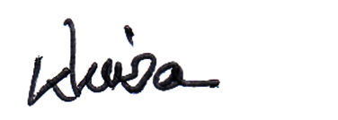
Md. Khaja Biswas

