RESUME
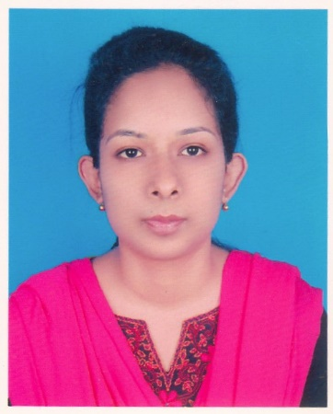
Of
KHALEDA SULTANA
Holding No-424/1, Word No-01,
Kulsumbagh, Charfassion Pouroshova. Bhola.
Mobile: +8801723853544
e-mail: sultanadithi@gmail.com

CAREER OBJECTIVE
To seek challenging job competitive environment where my knowledge and ability can be utilized to yield the maximum benefit to the organization as well as myself and want to work as a dedicated, devoted, dynamic and energetic employee.

PESONAL INFORMATION
Applicant Name : Khaleda Sultana
Father’s Name : Md. Abdul Khaleque
Mother’s Name : Jesmin Ara
Date of Birth : 01-02-1991
Permanent Address : Holding No-424/1, Word No-01, Kulsumbagh,
Charfassion Pouroshova. Bhola.
Present Address : Holding No-424/1, Word No-01, Kulsumbagh,
Charfassion Pouroshova. Bhola.
Nationality : Bangladeshi
Religion : Islam
Marital Status : Unmarried
Blood Group : B^{+ve}
National ID No : 19919115329000143

EDUCATIONAL QUALIFICATIONS:
M.S.S (Masters)
Name of Institute : Govt. B M College, Barishal
Subject Name : Economics
Result : C.G.P.A-3.16
Passing Year : 2014
Board : National University

B.S.S (Honor’s)
Name of Institute : Govt. B M College, Barishal
Subject Name : Economics
Result : C.G.P.A-2.96
Passing Year : 2013
Board : National University

H.S.C (Higher Secondary Certificate)
Name of Institute : Jalalabad Cantonment Public School & College, Sylhet
Group Name : Humanities
Result : G.P.A-4.10
Passing Year : 2009
Board : Sylhet

S.S.C (Secondary School Certificate)
Name of Institute : Jalalabad Cantonment Board High School, Sylhet
Group Name : Humanities
Result : G.P.A-4.06
Passing Year : 2007
Board : Sylhet

LANGUAGE SKILLS
I have good command over Speaking, Reading & Writing in both Bangla and English.
COMPUTER SKILLS
Computer Basic Course, (Ms Word, Ms Excel, Ms Power Point, Internet & E-mail)
INTEREST
Inquisitive about world affairs, watching TV News, Reading Books, Listening Music & Travelling.
REFERENCE
Md. Aktaruzzaman Khan Shumana Sharmin
Associate Professor Lecturer
Department of Economics Department Of Accounting
Govt. B M College, Barishal Govt. B M College, Barishal
Mobile: 01716841166 Mobile :01711970226

Date:....................................... Signature:......................................

