Curriculum Vitae
OF
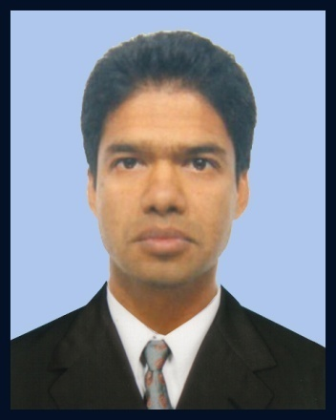
MD KAMAL HOSSAIN

MD KAMAL HOSSAIN
SAMS ATTIRE LTD
10th Buhyian Tower
Asulia , Savar.Dhaka.
Email : kamal.sams.att@gmail.com
Cell: 01940107544.
Career Objective:

To work for an organization using my knowledge and experience based skills to the best of my ability to achieve best results and to add value to my post together with initiative ideas. My ultimate aim is to work as an active member of an energetic team in a large environment so that I can exploit my full potential.

Experience:
Present:
Serving in SAMS ATTIRE LTD as “Assistant Merchandiser ” from 24th November, 2012 to still now.

Major work & Responsibilities:
- Costing & Price negotiation with buyer
- All type of development as per buyer requirement.
- Estimate booking for fabric & all others accessories.
- Prepare package for the approval of fabric & accessories.
- Prepare package for Lab-Test of fabric/garments as to be required by the buyer for the instruction of care label.
- To monitor quality & quantity of the all materials and garments.
- Follow up all garment production process as per time schedule.
- To monitor packing instruction, final-inspaction & shipment arrangement as per time schedule.
BUYERS: Little Woods , Hema , Grow, Gymboree.

Educational  Qualification | Title | : | Master’s of Commerce
 | Institute | : | Comilla gvt Victoria College.
 | Subject | : | Management.
 | Course Duration | : | One Year
 | Result Obtained | : | 2nd Class
 | Session | : | 2001-2002 (held in 2005)
 | Title | : | Bachelor of Commerce
 | Institution | : | Comilla gvt Victoria College.
 | Subject | : | Management .
 | Course Duration | : | 3 Years
 | Result Obtained | : | 2nd class
 | Session | : | 1998-99
 | Pass of the Year | : | 2003
 | Title | : | Higher Secondary School Certificate (H.S.C)
 | Institution | : | Comilla Victoria College
 | Subject | : | Commerce
 | Result Obtained | : | 2nd Division
 | Pass of year | : | 1998
 | Board | : | Comilla
 | Title | : | Secondary School Certificate(S.S.C)
 | Institution | : | Ibne Taimiya School
 | Subject | : | Science
 | Result Obtained | : | First Division
 | Pass of year | : | 1996
 | Board | : | Comilla
Personal Information | Name | : | Mohammad Kamal Hossain
 | Father’s Name | : | Late Md Abdul Mannan.
 | Mother’s Name | : | Komola Begum.
 | Date of Birth | : | 1st July, 1981.
 | Nationality | : | Bangladeshi (by birth)
 | Religion | : | Islam
 | Sex | : | Male
 | Height & Weight | : | 5 feet 3 inch & 54 kg.
 | Marital status | : | Married
Permanent Address
Permanent Address | Name | : | Mohammad Kamal Hossain.
Permanent Address | Son of | : | Late Md Abdul Mannan.
Permanent Address | Village | : | Ashwdia.
Permanent Address | Post office | : | Hazipur.
Permanent Address | Police Station | : | Laksam.
Permanent Address | District | : | Comilla.
Computer  Literacy | Course Name | : | MS-Word, MS–Excel, MS–Power Point, Internet and e-mail.
Language Knowledge: Good command over speaking, reading & writing in Bengali, English & Italian.

Reference | Chanchal Mazumder  Manager Operation  SAMS ATTIRE LTD  10th Buhyian Tower  Asulia , Savar.Dhaka Cell: 01818591497.

Declaration of Authenticity:
I do hereby declare that all information here is true to my knowledge. If required and where applicable, this document can be supported by appropriate authentic certificates/Papers.

……………………………………………
Mohammad Kamal Hossain

