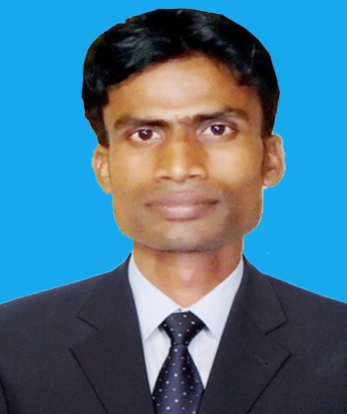
Curriculum Vitae
Of
Krisna Golder
C/O: late Thakur Das Golder
Village: 15 Hazi Ismail Link Road,Banorgati,Khulna.
Post Office: Sonadangta (1900), Thana: Sonadanga,
Zilla : Khulna, District: Khulna Bangladesh
Cell Phone : 01732-220863,0911-576417
Email : krishnagolder1989@gmail.com

CAREER OBJECTIVE
To work in an environment where is an opportunity of self-assessment
and improvement in both individual and group-based jobs that frequently
faces with individual skills.

PERSONAL STRENGTHS
I am self-motivated, intelligent and diligent and ready to go the extra leg
to achieve the target, I have set for myself. I am a natural team player and
I can lead and be led, as the situation requires. I am an optimist by nature
and have a good sense of humor.

PERSONAL INFORMATION
Name : Krisna Golder
Father's Name : LateThakur Das Golder
Mother's Name :Late Anaroti Golder
Date of Birth : 10th june 1989
Nationality : Bangladeshi (By Birth)
Sex : Male
Religion : Hindu
Marital Status : Unmarried
Cell Phone : 01732-220863,0911-576417
Email : krishnagolder1989@gmail.com

MAILING
ADDRESS
C/O: late Thakur Das Golder
Village: 15 Hazi Ismail Link Road,Banorgati,Khulna.
Post Office: Sonadangta (1900), Thana: Somadanga
,Zila : Khulna District: Khulna
Banglades
MASTERS OF BUSINESS ADMINITRATIONS
Name of Institute : Azam khan commerch College,,Khulna.
University : National University
Subject : Marketing
Year : 2012
Result : Second Class

BACHELOR OF ARTS ( HONERS )
Name of Institute : Govt Barishal College, Barishal
University : National University
Subject : Merketing
Year : 2011
Result : Second Class

HIGHER SECONDARY CERTIFICATE (H.S.C)
Name of Institute : Khulna Shahid suhrawardy college,Banorgati,Khulna
Board : Jessor
Group : Commerch
Year : 2007
Result : G.P.A-3.20
SECONDARY SCHOOL CERTIFICATE (S.S.C)
Name of Institute : Pallimangol High school,Khulna.
Board : Jessor.
Group : Science
Year : 2005
Result : G.P.A-3.13
COMPUTER LITERACY

Program: MS Word, MS Excel, MS Power Point,

Operating System: Windows XP, vista, Win 7, Win 8.

Performance : Good

INTEREST & HOBBIES
Photography, Sports (cricket), Traveling, Listening Music.

COMMUNICATION SKILLS
Good written and communication skills both in Bengali and English I am undersigned, hereby declare that
EXPERIENCE : I Have been working as a union facilitator under the Partners in health and development (PHD) since 2 years

I will be responsible for my wrong information provided
here..
Krisna Golder

