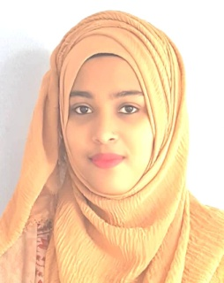
LILI BEGUM
Phone : 017755837454
Email : lilibegum0807@gmail.com
Permanent Address : Dawrai,Jagannathpur,Sunamganj

CAREER OBJECTIVE
To obtain a responsible career, where I could optimally utilized my education, qualification as well as gained professional experience for making significant contribution in a progressive and dynamic organization.

ACADEMIC QUALIFICATION
Exam Title | Concentration/ Group | Institute | Result | Passing Year | Duration
Computer Science & Engineering  (CSE) | B.Sc (Hons)  152 Credit | Leading University, Sylhet | CGPA: 3.21  out of 4 | 2018 | 4th year
HSC | Science | Scholarshome Girls College | GPA: 4.30  out of 5 | 2014 | 2 year
SSC | Science | SharopollI High School & College | GPA: 4.25  out of 5 | 2012 | 2 year

Training Summary:
Training Title | Topic | Institute | Country | Location | Year | Duration
ICT Web-development training for girls | Website Development Training | Shahajalal University of Science & Technology. | Bangladesh | Sylhet | 2016 | 1 day

Career Summary | - Working knowledge in IT sector  - Performed website design and development.  - Creating website compatible with mobile.  - Ability to give estimates on work required.  - Quick learner
Special Qualification | - ACM programmer. Attending various programming contest  - Programming Language: C, C++, JAVA, PHP, Android, JavaScript, jQuery  - Excellent skill in HTML, CSS & MySQL etc.
Extracurricular Activities | - Participated in seminars and workshops (Computer Club, Leading University)  - Participated in sports competition (Leading University, Annual Sport Competition)  - Participated in social activities. (Social Servicing Club, Leading University)

Language Competency | - Bangali & English

Reference:
Rumel M. Saifur Rahman Pir  Assistant Professor  Department of CSE  Leading University, Sylhet  Contact Information  Phone: 01758228736  Email: rumelpir@gmail.com | Md. Asaduzzaman Khan  Assistant Professor  Head ( Acting )  Department of CSE  Leading University, Sylhet  Contact Information  Cell Phone: +8801711003233  E-mail: head_cse@lus.ac.bd

Signature

…………………………………….….
(Lili Begum )

