CURRICULUM VITAE OF
Mahadi Hasan Chowdhury

MAILING ADDRESS:
Molaitilah,botesswor.
Jalalabad cantonment-3104,Sylhet
Cell Phone: +8801408072996
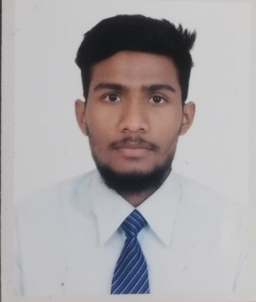
Email: mahadihasan8835@gmail.com

CAREER OBJECTIVE:

❖ I am a motivated and hard-working individual. I display confidence, as an individual, and am an excellent team player. I am able to communicate with people of all levels, and display my ideas clearly. I wish to pursue a career in a market leading organization to gain utmost competence and add value to business, society and economy through professionalism.

ACADEMIC BACKGROUND:

Higher Secondary Certificate (HSC)

Institution : Jalalabad Cantonment Public School & College Board : Sylhet
Group : Science
Year of Passing : 2017
Obtained GPA : 5.00

Secondary School Certificate (SSC)

Institution : Chiknagul adorsho high School
Board : Sylhet
Group : Science
Year of Passing : 2015
Obtained GPA : 4.56 in a scale of 5.00

LANGUAGE SKILLS:
Excellent command over Bangla & English (both in Reading, Writing, Listening & Speaking)

IELTS (Academic):
Obtained an overall band 5.5 with the following specific band score 5, 5.5, 5.5 & 5 in listening, reading, writing & speaking module respectively.

COMPUTER SKILLS:

• Office Packages: MS Word, MS Excel, MS Access & MS PowerPoint.
• Excellent knowledge in using Internet, e-applications, emails & Internet research.

PERSONAL INFORMATION:
• Father’s Name : Sirajul Islam
• Mother’s Name : Nasima khatun
• Date of Birth : 18th August, 1998
• Nationality : Bangladeshi
• Religion : Islam
• Sex : Male
• Marital Status : Single
• Present Address : Molaitilah, botesswor,Jalalabad cantonment-3104, Sylhet
• Permanent Address : Sungoir,sreemongol,Moulovibazar, Sylhet

I hereby declare that the information stated above is correct to the best of my knowledge.

(Mahadi Hasan Chowdhury)

