MAKDIA HUSSAIN | 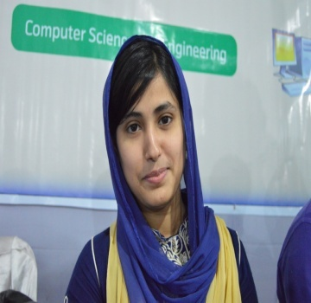
ANDROID & WEB DEVELOPER
Contact: +8801840392204
E-mail: makdiahussain81@gmail.com

Career Objective:
An internship or research opportunity that will allow me to utilize my problem solving skills and attention to detail to further develop my abilities in the field of computer science .I mostly like anything that involves a nice touch of logic, but often find myself specifically attracted to creative programming, to work in a challenging environment, achieve skills in the respective field and work for the simultaneous progression of organization and myself.

Academic Qualification:
Programs | Institution | Board | Department | Grade | Year
BSC | Metropolitan University, Sylhet | SYLHET | CSE | 3.94 | 2018
H.S.C | Beanibazar Govt. College, Sylhet | SYLHET | Science | A+ | 2012
S.S.C | Beanibazar Girls High School, Sylhet | SYLHET | Science | A | 2010
Professional Experience:
- Android & web developer at Panacea-IT, Amborkana, Sylhet (Since 2017)
- Working as a private tutor(Since 2017)

Achievements:

- Kaizen SUST best project award 2017.
- Sylhet city science fair 1st runner up 2015.

Career and Application Information:
Looking For | : | Entry Level Job /Data entry /Android development/Teacher
Available For | : | Full Time/part time /online
Preferred Job Category | : | IT/University/College/School
Preferred District | : | Sylhet

Skills

Programming Languages C/C++ (Proficient), Java (Proficient)

Web Programming HTML, CSS, HTML5 & CSS3, Bootstrap, PHP, SQL, MYSQL

Familiar With Python, JQuery, MATLAB, Arduino, x86 assembly, x64 assembly

Mobile Programming Android, JSON, Firebase, SQLite, XML

Development/ Environment Windows, Netbeans IDE, Eclipse, Android Studio, MYSQL, OpenGL,
Tools/ Technologies ASP.NET, Microsoft Office

Done Project:

- FoodBuzz (Restaurant Maintenance, food order, fast delivery ,online payment)
- Easy Math (https://play.google.com/store/apps/details?id=edu.metrouni.team7.EasyMath)
- Quick Swap (https://play.google.com/store/apps/details?id=com.Quick.swap.transaction2)
- Mu Routine Dynamic (https://play.google.com/store/apps/details?id=edu.metrouni.routine)
- Medical Portal (Hospitals & Doctors details information and other services)
- Tour guideline (Tourist place details information, location with Google map, rating & review system)
- Ask Question (Ask education related question , quick response, sell book)
- TextVoice (The app to learn language (English) by repeated listening)
- Shared Task (To share task mainly with friends and family members)
- E-commerce website

Language Proficiency:
Language | Reading | Writing | Speaking
English | High | Medium | Medium
Bangla | High | High | High

Strengths :
- Skilled at programming, from low-level Assembly to Object-Oriented Java/C
- Good experience with android development
- Good working knowledge of Web Servers (Apache)
- Adept at Design and implementation of algorithms
- Good at Mathematics
- Ability to work in the team and individual and management skills
- Motive to learn
- Inherent capability of communication with people

Personal Background :
Father’s Name : Md. Altaf Hussain
Mother’s Name : Rukshana Begum
Date of birth : 11-01-1994
Gender : Female
Religion : Islam
Nationality : Bangladeshi
Marital Status : Unmarried
Permanent Address : Vill-Chondogram, Upozilla-Beanibazar,Dist-Sylhet.
Current Address : Tantipara, Zindabazar, Sylhet.

I hereby declare that the above statements are correct and complete to the best of my knowledge.

----------------------------
Makdia Hussain
Date: 7th March 2018

