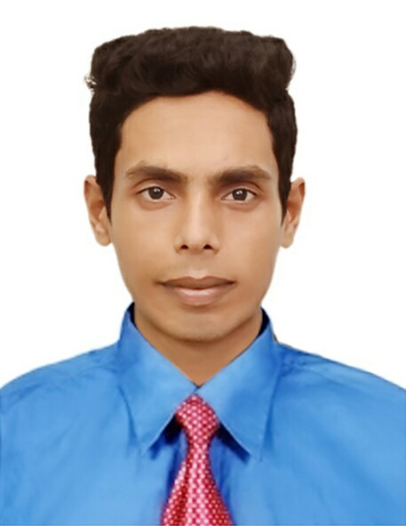
CURRICULUM VITAE

MD. SAZZAD HOSSAIN
Mobile: +8801684916365
PRAN Tasty Treat Factory
Jokigonj Road, Kodomtoli, Sylhet

E-mail: hossainsazzad376@gmail.com

CAREER & APPLICATION INFORMATION

CAREER OBJECTIV:

I would like to build up my career of Engineering Sector through using my creatively, efficiency, proficiency and hard working so that my respective organization can achieve its goal in the circumstance of the global challenge and competition. I always prefer to take the challenges as opportunities for building up myself.

 | ACADEMIC QUALIFICATION
Secondary School Certificate (General)
Institute | : Noyabari High School
Group | : Humanities
Board | : Dhaka Board.
Year of passing | : 2011
Result GPA | : 4.38 (Out of 5.00).
Diploma in Engineering
Institute | : Sylhet Polytechnic Institute
Department | : Computer Technology
Duration | : Four Years.
Board | : Bangladesh Technical Education Board.
Year of passing | : 2015
Result CGPA | : 2.60(Out of 4.00)

TRANING SESSION & WORKING EXPRIENCE

Have more than 3 months training Experience on CCNA (OPEN IT LTD) Mirpur, Dhaka-1207
Experience:

I have more than 2 Year job experience as a Sub Assistant Manager-MIS at Pran Tasty Treat Factory, Jokigonj road, Kodomtoli, Sylhet.

EXTRA CURRICULUM ACTIVITIES

I include list some special skills that can add to my competency for the desired job Position:
Windows Server, Hardware, Network, CCTV, IP Camera, DVR, NDVR, ERP Software

 |  | PERSONAL INFORMATION
Name |  | : Md. Sazzad Hossain
Father's Name |  | : Md. Abu Sayeed
Mother's Name |  | : Mst. Parvin Akter
Date of Birth |  | : 12/02/1996
Height |  | : 5'-6"
Weight |  | : 55 Kg
Sex |  | : Male
Religion |  | : Islam
Marital Status |  | : Unmarried
Nationality |  | : Bangladeshi (By Birth)
Mailing Address |  | : Vill: Borropagla, P.O: Bibirchar
 |  | P.S: Nakla, Dist : Sherpur
Permanent Address |  | : Vill: Borropagla, P.O: Bibirchar
 |  | P.S: Nakla, Dist : Sherpur

INTERESTS

I am able to work in a team Environment, Reading, Teaching, Traveling, and in challenging works.

DECLARATION

I am undersigned, hereby declare that at the information included here are true to my knowledge. If required and where applicable, this document can be supported by appropriate authentic certificates.

Language Ability

Bangla is Mother Tongue.

English Speaking & Writing Excellent.

REFERENCE
Engr. Abdullah INB Nazim Md. Abdul Momen
Instructor (Computer Technology) Medical Information Officer
Sylhet Polytechnic Institute, Sylhet Popular pharmaceuticals Ltd.
Mob: 01756 182176 Mob: 01712 895111

Md. Sazzad Hossain Date:

