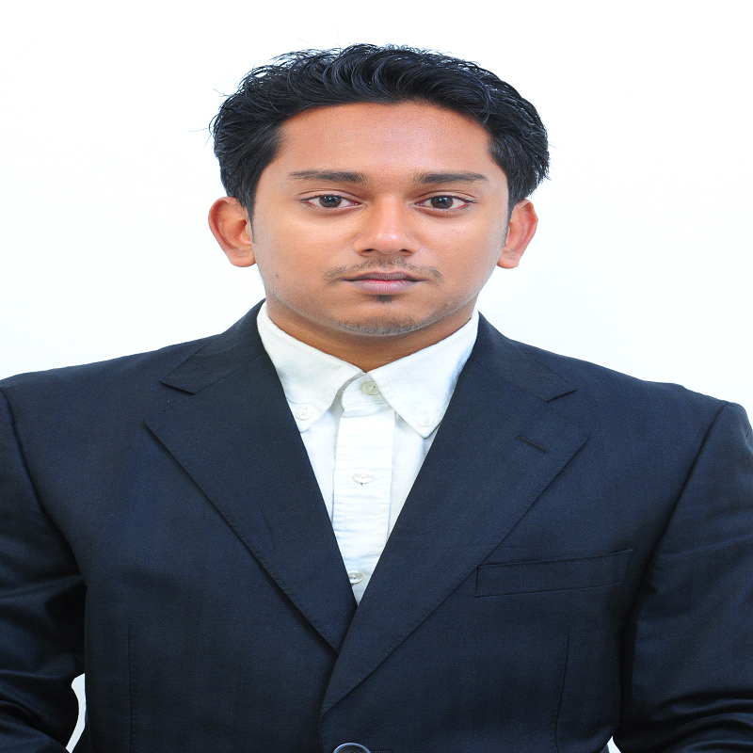 CARRICULAM VITAE MD. SHAFIUR RAHMAN HASAN
Contract: 01717-896126
Email: shafiur.hasan@gmail.com
& Shafiur.hasan13@gmail.com
Personal Information
Father’s Name : Aftab Uddin
Mother’s Name :Ayesha Begum
Parmanent Address : Vill:Shimultola, P.O: Badaghat,
P.S.: Tahirpur, Dist.: Sunamgonj.
Present Address : Raynagar Jalalabad Gas Stuff Complex, Sylhet.
Nationality : Bangladeshi By Birth
Date of Birth : 01/10/1992
Gender : Male
Religion : Islam
Maritual Status :Single

Academic Qualification
NAME OF EXAM | PASSING YEAR | GPA | GROUP/SUBJECT | BOARD OF UNIVERSITY
SSC | 2009 | 4.44 | SCIENCE | SYLHET
HSC | 2011 | 3.20 | BUSINESS | SYLHET
HONOURS | 2016 | Appeared | BBA(Accounting) | National University Of Bangladesh
IELTS | 2014-1015 | 5.5
Basic Skills
I have enough efficiency in :-
# Basic computer literacy,
# Efficient in Ms word,
# Ms Excel,
# Power Point,
#Internet &Email.
# Bangla and Engligh type

Job Skill
I used to work at Faithfone Call Center from 2016-2017 as a ecommerce support and customer support executive. And then work for UK Business Solutions administration for last 6 months. Currently working for Posari IT Solutions (http://posari.com/)

Sincerely Yours
Hasan

MD. Shafiur Rahman Hasan

