MD. MOYLAL HOSSAIN | 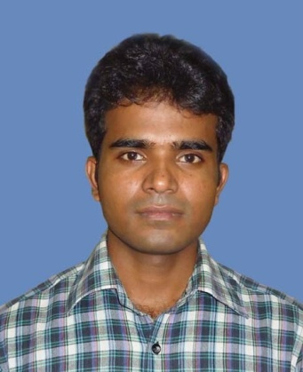
Address: Dhrubotara Chatrabas, Kajla, Motihar, Rajshahi-6205
Home Phone: 01723814522
Office Phone :01750331011
Mobile : 01983729038
e-mail:sujon.chemru73@gmail.com

Career Objective:
To work in an environment where can utilize what I have learnt theoretically and apply them to practical situations while simultaneously refining my extensive set of personal skills.

Special Qualification:
Applications : MS Word, MS Excel, MS PowerPoint, Photoshop. Internet : Very familiar with Internet Browsing, Downloading, E-mailing.

Academic Qualification:
Exam Title | Concentration/Major | Institute | Result | Pas.Year | Duration
M.Sc | Organic chemistry | Rajshahi University | Appeared | 2012 | 1 year
B.Sc | Chemistry | Rajshahi University | CGPA:2.99  out of 4 | 2011 | 4 years
HSC | Science | Professor Boyen Uddin College | CGPA:3.9  out of 5 | 2006 | 2 years
SSC | Science | Chiknai High School | CGPA:4.13  out of 5 | 2004 | -

Career and Application Information:
Looking For | : | Entry Level Job.
Available For | : | Full Time.
Expected Salary | : | Tk. 20000
Preferred Job Category | : | Medical/Pharmaceutical, Garments/Textile.
Preferred District | : | Anywhere in Bangladesh.
Preferred Country | : | Germany, India, Japan, Malaysia, Saudi Arabia, United Kingdom, United States, Canada, France, Singapore.
Preferred Organization Types | : | Pharmaceutical/Medicine Companies, Medical Equipment, Chemical Industries, Garments (Woven/Apparel/Knitting.

Personal Details :
Father's Name | : | Md. Ansar Ali
Mother's Name | : | Mrs. Joynab Khatun
Date of Birth | : | November 15, 1988
Gender | : | Male
Marital Status | : | Unmarried
Nationality | : | Bangladeshi
Religion | : | Muslim
Permanent Address | : | Vill: Mulgram, Post: Pachuria, PS: Chatmohor, Dist: Pabna
Current Location | : | Rajshahi

