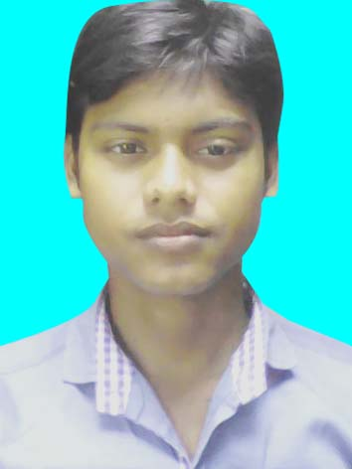
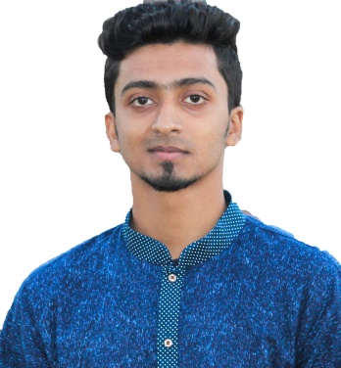
CurriculumVitaeof

MORSALIN AHMMED

Mailing Address: morsalin.org34@gmail.com

Mobile: +8801768801834, 016-x xxx
E-mail: morsalin.org34@gmail.com

janathansmith@gmail.com
CAREER OBJECTIVE
Looking for hard and Challenging Job where I will have the scope to utilize my potentiality, adaptability and skill to do something innovate and from where I will be able to enhance my knowledge.

EDUCATIONAL BACKGROUND
Diploma in Engineering
Technology : Computer.
Institution : Imperial Polytechnic Institute.
Location : Shantimore. Chapai Nawbgonj
Result : 3.57
Passing Year : 2018

Board : Bangladesh Technical Education Board.

Secondary School Certificate (SSC)
Institution : Rajbari High School
Group : Science
Location : Rajbari hat, Nachole, Chapai Nawbgonj
Result : 4.31
Passing Year : 2013
Board :Bangladesh Technical Education Board

TRAINING BACKGROUND
ProfessionalWeb Design
Institution : Creative IT Institute Of Bangladesh.
Location :House# 07, Road# 04, Dhanmondi, 1205 Dhaka, Bangladesh.
Duration : Six month.
Passing Year : 2018.

COMPUTER SKILLS

Application Package : MS. Word, MS. Excel & MS. PowerPoint.
Web Design :Programming Languages (HTML, CSS, JavaScript, PHP, Wordpress Theme Customization)

LANGUAGE PROFICIENCY
Bangla
English

PERSONAL INFORMATION
Full Name : Morsalin ahmmed
Father Name’s : Mojibur Rhaman
Mother Name’s : Nadira Begum
Permanent Address : Kuarpur, Rajbari-hat, Niamotpur, Naogaon

Date of Birth :02thSeptember, 1998
National ID/Birth certificate :BC: 19986416963038003
Blood Group :O+
Marital Status :Single
Religion : Islam
Nationality : Bangladeshi
Hobby :Programming

REFERENCES
Shompa Parvin
Executive Director
Creative IT Institute
Momtaz Plaza (4th Floor), Road # 04,
House # 07, Dhanmondi, Dhaka- 1205.
Cell: 01990779977
E-mail: ed.cit.inst@gmail.com

Morsalin.
.................................
Signature
THANKS FOR WATCHING

