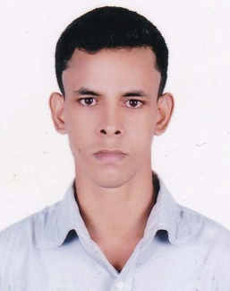
RESUME
Of
Mohammad Mahid Khan
Cell number: 01740199420
Email: mdmahidkhan3@gmail.com

WHAT MAKE DIFFERENT:

I am self motivate, intelligence, diligent and ready to give my best effort to achieve the target. I am natural player and can lead able led the situation requires. I am an optimist by nature and have a good sense of humor.

OBJECTIVE:
I would like to be a part of an organization where I can get chance to apply all my theoretical and practical skills as well as get opportunity to learn advance publications and technologies related to my profession.

EDUCATIONAL QUALIFICATION:

4 YEARS DIPLOMA ENGINEERING:

Examination : Diploma in Engineering
Institution : Habiganj Polytechnic Institute, Habiganj
Group : Electronics
Board : Bangladesh Technical Education Board
Year of passing : 2015.
GPA : 3.05 (out of 4.00)

SECONDARY SCHOOL CERTIFICATE:

Examination : S.S.C
Institution : Habiganj Technical School & College
Group : General Electrical Works
Board : Bangladesh Technical Education Board
Year of passing : 2011.
GPA : 4.38

PERSONAL DETAILS:
Name : Mohammad Mahid Khan
Father’s Name : Mohammad Mahmud Hussain Khan
Mother’s Name : Mosammat Shirina Chowdury
Date of Birth : 22nd November 1993.
Present Address : Ka/97, Jomoj Road, Joar Shahar, Vatara. Dhaka-1229
Permanent Address : Village- Begunai, P.O-Madna, P.S-Lakhai,
Dist-Habiganj.
Nationality : Bangladeshi.
Marital status : Single.
Gender : Male.
Religion : Islam
Blood Group : O+
Home District : Habiganj.

LANGUAGE PROFICENCY:
Excellent communicative capabilities both Bengali and English.

DEPARTMENT PROFICENCY:
Basic Electrical, Basic Electronics. Basic Microcontroller and PLC.

COMPUTER SKILLS:
1. Application Software : (MS Word, MS Excel, MS Access)
(English typing speed of minimum 25 words per minute.)
2. Internet Explorer : (E-mail, Voice-mail, Internet Browsing etc.)

EXPERIENCE:
Worked in as a Data Entry Operator at IIMl form 15th December’16 to 30th June’17.

REFERENCE:

Fakhrul Islam Chowdhury
Chief Instructor, Electronics Technology.
Habiganj Polytechnic Institute.
Phone:- 01558-347266
Email-fakhrulc9@gmail.com

I, the undersigned, certify that all the given information above about my educational qualifications and personal particulars are absolutely correct.

Date:………………… Mohammad Mahid khan

