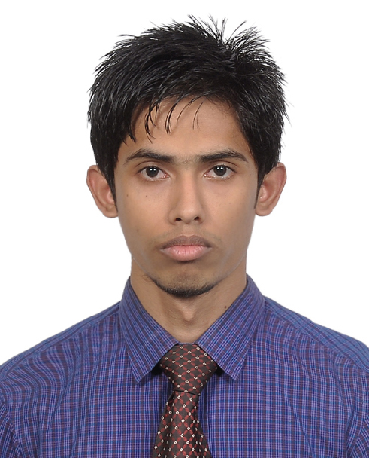

Resume of
Mujib Husen

Present Address:
Contact Address:
E-mail : mimhusen@gmail.com
Cell Phone : +88-01813515044

25/A, Modushohid, Sylhet
Sylhet-3100.

Career Objective
Searching for a desirable opportunity with which I will have the scope in utilizing my skills and potentiality to do something innovative and from which I will be able to enhance my knowledge and efficiency.

Educational Qualification

Qualification | Major/Group | Board/  University | Passing Year | Result | Grade
B.B.A. | Finance  &  Banking | Leading  University | 2016 | CGPA 2.54  (Out of 4) | C
H.S.C. | Commerce | Sylhet | 2012 | GPA 3.30  (Out of 5) | B
S.S.C. | Humanities | Sylhet | 2010 | GPA 3.44  (Out of 5) | B

Computer Knowledge

- Able to prepare any type of documents with MS word, Ms excel, Ms PowerPoint.
- Having knowledge on Internet browsing and e-mail.
- Having knowledge on Web Development ( HTML, CSS, PHP, WordPress ).

Language Proficiency

- Bengali (Mother tongue).
- English (Fluent in reading, writing and acceptable in speaking).
- Have done the Spoken English course.

Self-Assessment

- Strong desires for leading an honest life with dignity.
- Aspiration to build a career showing superior performance.
- Energetic, sincere, hard working, honest and Dutiful.
- Able to work at any time at any place.
- Ability to work with a team.

Personal Profile

Name : Mujib Husen
Father’s Name : Aktar Husen
Mother’s Name : Sorifa Begum
Present address : 25/A, Modushohid, Sylhet, Sylhet-3100
Permanent address : Chandgram, Barlekha, Moulvibazar, Chandgram-3171
Date of Birth : 10th April, 1993.
Contact Number : +88-01813-515044
Nationality : Bangladeshi (By Birth).
Religion : Islam.

References
References

1. Mohammed Zahed Hussain  Senior Lecturer  Department of Business Administration  Leading University, Sylhet.  Cell: +88-01816-555545 | 2. Md. Hafizur Rahman Khan  Senior Lecturer  Department of Business Administration  Leading University, Sylhet.  Cell:+8801737401135

Declaration

I would be appreciated if you give me an opportunity to work with you and to execute myself with your support. All the information provided here are correct and complete.

Yours Sincerely,

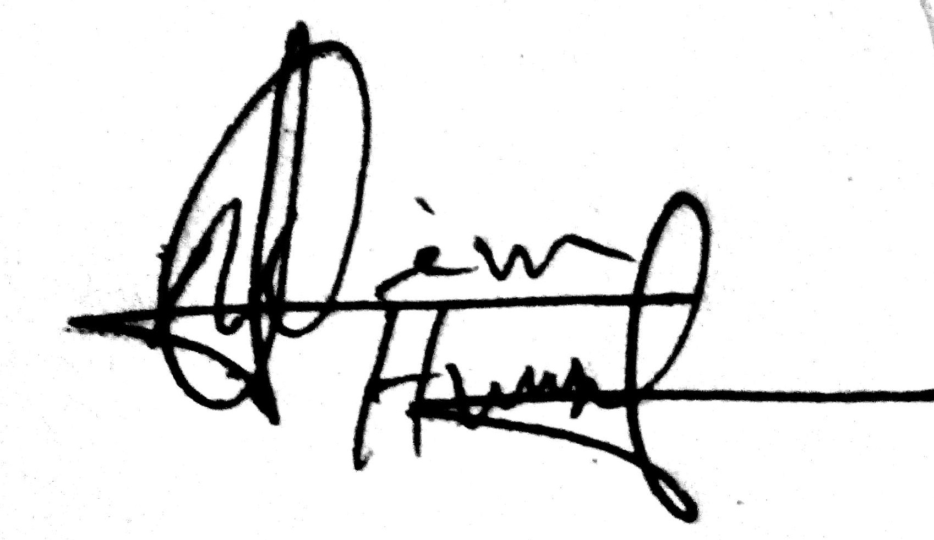
Mujib Husen

