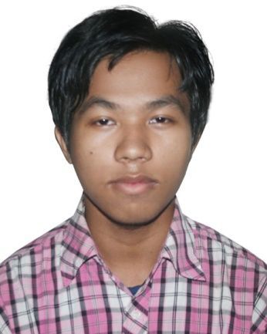

CURRICULUM VITAE OF
Mayengbam Manendra
Contact no.:01701803164
Taher Manjil , Madanibag, Sylhet .
E-mail: mukesh.singha444@gmail.com

Career Objective:
I can work independently using my own initiative or as a part of a team.
Academic Qualification:
Exam Title | Institution/ Board | GPA/CGPA | Passing Year
B.A | Dakshin Surma College & University. |  | Running
H.S.C | Sylhet | 2.30 | 2014
S.S.C | Sylhet | 3.25 | `2011

Extra Curricular Activities:
- Worked as a sales Agent at
- Bell
- Aarong
- Kamala Vandar
- Skytech (Call-Center)

IT SKILL: Windows operating, Office Administration & Main tainence, MS Office, Graphics Designing ( Adobe Platform)
EXPERIENCE: Sales management, Stock maintainence, Customer Relationship, Accoountancy, Data entry, Documents researching
OTHER SKILLS: # Maximum Knowledge at Exhibition & Event Management
#Good Knowledge at File Maintainence & Book Keeping

- Language Proficiency: Fluent at English (US accent) and Bengali

Personal Details:
Name : Mayengbam Manendra
Father’s Name : Mohendro Kumar Singho
Mother’s Name : Mayengbam Monjushree
Date of Birth : 05.10.1995
Gender : Male
Nationality : Bangladeshi
Marital Status : Unmarried
Blood Group : O (+ve)
Present Address : Taher Manjil , Madanibag, Sylhet Cell Number : 01701803164
Permanent Address : Abadgaon, Gazipur, Chunarughat, Hobiganj.

I hereby declare that the above statements are correct and complete to the best of my knowledge.

Yours faithfully,

........................................
Mayengbam Manendra

