CURRICULUM VITAE
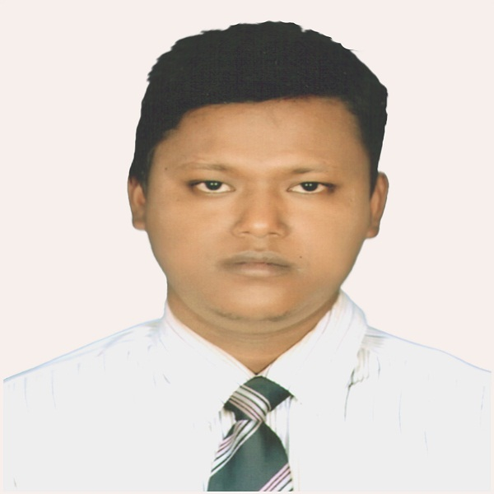

Priyanath Roy

B.Sc in Civil Engineering (CUET)

351(7th Floor, 7C) Senpara, Porbota

Mirpur-10, Dhaka

Contact no.: +8801738221889

+8801774559259

E-mail: prio_cuet @yahoo.com
Objective:
To work in a challenging environment and be known for depth of knowledge, quality, hard work, timeliness of service, and honoring the commitments.
Education:

2012
B.Sc. in Civil Engineering

University name : Chittagong University of Engineering & Technology.
Department : Civil Engineering
CGPA : 2.98 (out of 4.00)

2007
Higher Secondary Certificate Examination (H.S.C)

Institution name : Samir Uddin Smrity College, Thakurgaon
Board : Rajshahi
Group : Science
Result : 4.60(out of 5.00)

2005
Secondary School Certificate Examination (S.S.C)
Institution name : Nekmord Alimuddin Govt. High School
Board : Rajshahi
Group : Science
Result : 4.25(out of 5.00)

“Water pollution in Karnaphuli River & its impact on aquatic lives”
Project:
Supervised by-
Prof. Dr. Swapan Kumar Palit
Department of Civil Engineering
CUET

Languages:

Good command in reading and writing both in Bengali and English.

Computer Skills:

Operating System:

- Windows (XP,VISTA,07)
Programming Language & Simulation Software:

- Auto CAD
- ETABS
Database, Document Processing:

- Microsoft Access, Microsoft Word, Microsoft Excel, Microsoft PowerPoint.
Tours:

✓ Karnaphuli hydro-electric power plant
✓ Bahaddarhat Flyover
✓ Raozan-Noapara power plant, Chittagong
✓ Tangkaboti Rubber Dam, Lohagara ; Chittagong

Name: Priyanath Roy
Personal Details:

Father’s Name: Samos Chandra Barmon
Mother’s Name: Binda Boni Roy
Permanent Address: Vill- Bhobanondapur, P.O.- Nekmord,
P.S-Ranisonkail, Dist-Thakurgoan
Date of Birth: jan 25, 1988
Nationality: Bangladeshi (by birth)
Marital Status: Single
Sex: Male
Blood Group: A+
Religion: Hindu
Preference: Dhaka based Real Estate Company
Reference:

Prof. Dr. Swapan Kumar Palit
Department of Civil Engineering
Chittagong University of Engineering &Technology (CUET)
Contact No: +8801713109967
E-mail: skpbd@cuet.ac.bd
Prof. Dr. Mahamood Omar Imam
Department of Civil Engineering,
Chittagong University of Engineering & Technology (CUET)
Cell Phone: +88 01713109900
E-mail: moimam@cuet.ac.bd

I, the undersigned, certify that to the best of my knowledge and belief, these data
correctly describe my qualifications and me.

…………………………..
Priyanath Roy

