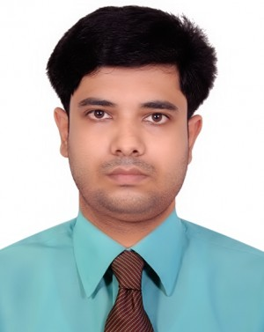
CURRICULUM VITAE
OF
Rownak Kayser Rafi

MAILING ADDRESS:

Rownak Kayser Rafi
Vill: Surot Pur, P.O: Brahmon Shason (3122)
P.S: Osmaninagar, Dist: Sylhet
Cell: 01770280204
Email:krafi1281@gmail.com

CAREER PLAN

Achieving a dynamic and Challenging job to utilize my academic knowledge and potentiality to development my career and to achieve a respectable and responsible position in the related field and thereby contributing for the welfare of the Institution.

EDUCATIONAL QUALIFICATION:

Secondary School Certificate (S.S.C)
Institute : M.C.N.K High School, Tajpur
Group : Science
Year of Passing : 2011
Result : 5.00
Board : Sylhet Board

Higher Secondary Certificate (H.S.C)
Institute : Shahjalal City College
Group : Science
Year of Passing : 2013
Result : 4.40
Board : Sylhet Board

Bachelor of Science (B.Sc Hon’s)
Institute : M.C. College, Sylhet
Subject : Physics
Year of Passing : 2017
Result : 3.46
University : National University

PERSONAL ATTRIBUTES:

⇒ Good organization and interpersonal communication skills
⇒ Ability to work in a team environment
⇒ Self-confident and being positive
⇒ Ability to manage time and being flexible
⇒ Ability to work efficiently under pressure and fulfill deadliness.

Computer Literacy:

Computer Office application & Internet Browsing.

LANGUAGE PROFICIENCY:

Bangla (Mother Tongue) : Well versed both in oral and written
English : Efficient both in oral and written

INTEREST:

Traveling, Playing, Reading Books & Newspaper.

PERSONAL DETAILS:

Name : Rownak Kayser Rafi
Father’s Name : Md. Amir Ali
Mother’s Name : Kohinur Khanam
Date of Birth : 24/11/1994
Marital Status : Single
Height : 5 Feet 8 Inch
Religion : Islam
Nationality : Bangladeshi by Birth
Home District : Sylhet
Blood Group : AB⁺ (ve)

PERMANENT ADDRESS:
Rownak Kayser Rafi
Vill: Surot Pur, P.O: Brahmon Shason (3122)
P.S: Osmaninagar, Dist: Sylhet
Cell: 01770280204

DECLARATION:
I hereby declare that the information provided in this resume in strictly maintained to
the best on my memory.

Rownak Kayser Rafi
Date:........................

