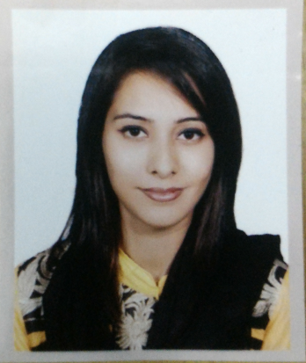
Resume of
Nazia Ahmed

Address: House# 29 tarango, lichubagan, mojumdari, sylhet - 3100.
Mobile: 01680-108-000
E-mail: Nazia06Ahmed@gmail.com
Career Objective:
My goal is to become associated with a company where I can utilize my skills and gain experience while enhancing the company’s productivity and reputation. Ideally, I wish to have a focus in end up my career being an example in my job sector.

Educational Details:
Bachelor of Business Administration (BBA)
Institute: Metropolitan University, Sylhet.
Result: CGPA 2.80
Passing year: 2018

Higher Secondary School Certificate (HSC).
Institute: Sylhet Govt. Women’s College, Sylhet.
Group: Humanities
Result: CGPA 4.00
Passing year: 2013

Secondary School Certificate (SSC).
Institute: Kazi Jalal Uddin Girls High School, Sylhet.
Group: Science
Result: CGPA 4.94
Passing year: 2011

Language Proficiency
Bengali: Native
English: Second language.
Profational Experience:

Designation: Office Executive
Worked from September 2018 to April 2019
Institution: Center For Education
Contact: info@cfeuk.com

Volunteer at British Council (as a student helper) from 2016 until the date.
Extra Curricular Activities:
Personal Information:

Father’s Name : Saad Uddin Ahmed
Mother’s Name : Fahmina Zarin
Date of Birth : August 6th, 1994
Blood Group : O+
Sex : female
Marital Status : Unmarried
Nationality : Bangladeshi
Religion : Islam

Address :

Present Address:
Address: House#29 tarango,
Lichubagan, Mojumdari,
Sylhet 3100.

References:

Mohammad Jamal Uddin  Coordinator. MBA  Dept. of Business Administration,  Metropolitan University, Sylhet.  Contact Info. Jamal@metro.uni.bd |  | Asif Iqbal  Business Development Coordinator Programs.  British Council  Contact Info. +88 01730 791 893  Asif.iqbal@bd.britishcouncil.org

I certify that the given information’s are true and wrong information will disqualify my application status.

Nazia Ahmed

