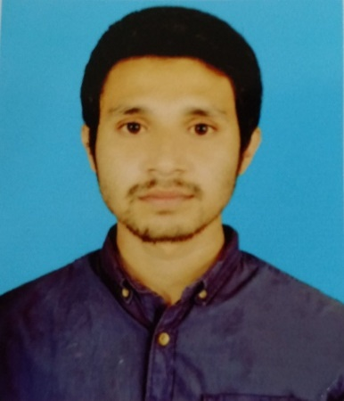

SAYEM ABDULLAH
Shornali D-5 R/A , Electric Supply Road ,Teghoria Suamganj-3000
Cell No. +8801719951195
Email: Sayem.ab@gmail.com

CARRIER OBJECTIVE
I want to develop sound professional career by honestly performing the assigned responsibilities given by the authority, which will create an opportunity to prove my abilities, and at the same time will help me to enrich the institution.

ACADEMIC STATUS
Bachelor of Science (Engg.) in Computer Science and Engineering
Leading University, Sylhet, Bangladesh.
CGPA: 2.73 out of 4.

Higher Secondary Certificate (HSC)
Sunamganj Govt. College, Sunamganj, Bangladesh.
CGPA: 3.80 out of 5.
Year of 2008 (Science)
Secondary School Certificate (SSC)
Govt. Jubilee High School, Sunamganj, Bangladesh.
CGPA: 4.00 out of 5.
Year of 2006 (Science)

PROFESSIONAL SKILL
Languages | : | PHP, HTML5,Css3, Javascript,Wordpress
Networking | : | Having Good Knowledge on LAN/WAN Management, IP Addressing, IP Routing , Network Devices(Hub , Switch ,Router) , IPBX, VoIP,Monitoring , Security Analyzing and Troubleshooting
Database | : | MySQL
Site Improvement | : | SEO, Site Loading Speed-Up, Site Security Analyzing
Operating Systems | : | Win 9x/XP, Win Vista, Win 7,Win 10, Linux.
Desktop FTP Client | : | FileZilla.
PROJECTS
University Networking Course Project:
- Setup Network for Small Office Using Packet Tracer

- Setup Network Using Various Network Topology

- Client-server Network

PERSONAL ATTITUDE
- Excellent logical, analytical and computational skills.
- Strong motivational and leadership skills
- Ability to work under pressure
- Ability to work individual as well as in team
- Continuous skill development approach
- Always positive, regardless of the challenge ahead.
- Willingness to work with emerging alternative technologies.
PERSONAL INFORMATION

Name | : | Sayem Abdullah
Father's Name | : | Haji Mahmud Ali
Mother’s Name | : | Husne Ara Begum
Date of Birth | : | 6th Jun, 1990
Religion | : | Islam
Marital Status | : | Single
Height &Weight | : | 5’.7” 60 Kg
Nationality | : | Bangladeshi

REFERENCE

Minhazul Haque Bhuiyan
Senior Lecturer
Convener, Project/Thesis Committee
Computer Science & Engineering
Cell Phone: +8801678174660
E-mail: minhazulriad@yahoo.com

