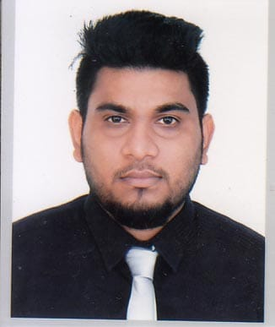
Rayhan Ahmed

Address:
Hatimbag, House -80/5,
Shibgonj,Sylhet, Bangladesh.
Cell :+88 01670106060,0717639029
E-mail :rayhan.ahmed0505@gmail.com
LinkedIn : rayhan.ahmed0505@gmail.com

- Career Objective

To work with a challenging ,growing and developing organization where there is a strong cultural environment of accepting ,sharing and rewarding better ideas and which can offer a wide group of performance with prudence ,sincerity honesty and efficiency to meet the challenges of the competitive world.
- Educational Record

Name of exam | Institute & Board | Passing Year | GPA / CGPA
MBA | Metropolitan University,  Sylhet | ongoing | Pending.
BBA  (Marketing) | Metropolitan University,  Sylhet | 2018 | 2.84
HSC  (Business Studies) | Modon Mohon College,Sylhet.Sylhet Board. | 2014 | 3.30
SSC  (Science) | Syed Hatim Ali High School, Sylhet, Sylhet Board. | 2012 | 4.50
- Award & Achievement

- Participating English Olympiad in 2018 (Organized by WOC).
- Participating Career Hacks in 2018 (Organized by MU),
- Participating Model United Nations (Organized by MUMUNA).
- Participating Basic operation of Accounting & Inventory Software name Tally.ERP9 & Factura.

- Experience

- Office Executive at Apex Oro Dental Care, Subhanighat for 2.5 years (March 2016-August 2018).
- Internship at United Commercial Bank ltd. Shibgong Branch, Sylhet, Bangladesh.
- Including It secretary at Organization of Human Rights & Social Environment Sylhet District.
- It Secretary at Shomobetho Jubho Shongho Hatimbag, Shibgonj, Sylhet.
- Extra-curricular Activities

- Campus Ambassador at English Olympiad (Organized by WOC).
- Arranged different programs
- Arranged program-International Mother Language, Independent, Intellectual & Victory Day
- Arranged workshop for Tally ERP9 & Factura at metropolitan University.
- Arranged League M in 2016,17 & 18.
- Arranged Department picnic in 2018.
- Arranged Department ifter mahfill in 2018.
- Seminar & Workshops

- Training on Tally ERP9 & Factura (arranged by Metropolitan University).
- Workshop on communication skill (organized by WOC).
- Workshop on Model United Nations (Organized by MUMUNA).
- Workshop on Career Development Career Hacks (Organized by MU).
- Workshop on Microsoft Excel (organized by GDN SUST).
- Computer Skill
- Have sufficient knowledge about using Tally ERP9 & Factura.
- Highly skilled in using Microsoft office software.
- Have sufficient knowledge about using SPSS.
- Extraordinary knowledge about computer fundamentals.
- Internet Browsing.
- Soft Skill

- Communication skill (passionate about it, specially maintaining relations with people & organization).
- Leadership skill (lead people & achieve goal).
- Good ability in speaking, reading, writing & listening both Bengali & English
- Personal Information

Father Name : Abdul Khalique
Mother Name : Akbori Begum
Permanent Address : Hatimbag House no-80/5,Shibgonj, Sylhet.
Date of Birth : 12-11-1995
Marital Status : Unmarried
Religion : Islam
Nationality : Bangladeshi
National ID : 9144121309
Hobbies : Watching TV, Reading magazine, Listening music, Sports, Traveling,.
- Reference

Md.Ruhel Ahmed  Executive Officer & Manager Operation  United Commercial Bank Ltd. Lamabazar Branch, Sylhet  Cell:+:+8801717567243  Email: Ruhel51@yahoo.com | Md. Afsarul Islam  Lecturer  Department of Business Administration  Metropolitan University  Sylhet  Cell:+8801726995249  E-mail: afsarul@metrouni.edu.bd
- Declaration

I hereby declare that, all the above provided information is true. Any alteration of that could be treated as disqualification.

Signature.
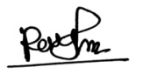 Date:
Rayhan Ahmed

