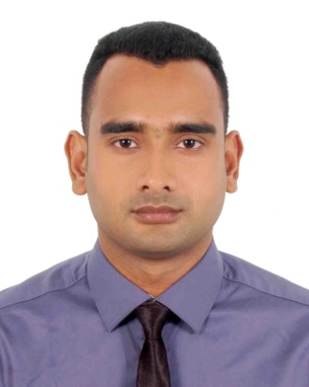
Curriculum Vitae
Md. Alamgir Hussen
MBA (Marketing)
BBA (Marketing)
Sylhet International University
Phone : 01722-660998
Email : alamgir_hussen@yahoo.com
Career Objective | To work in an environment where there is an opportunity of self-assessment and self-improvement in both individual and group based work that will ultimately lead to the further development of the professional level.
Career History | Junior Accountant,  SYLTECH Scaffold 7th January 2018 – Till now  Responsibilities:  Maintain daily cashbook  Maintain general ledge  Prepare monthly profit and loss statement
Members | Yeas member of Transparency International Bangladesh  Member, Rotaract Club of Sylhet International University
Educational Qualification | Masters of Business Administration  Major: Marketing  Result: 3.29  Passing Year: 2019  Sylhet International University  Bachelors of Business Administration  Major: Marketing  Result: 3.00  Passing Year: 2017  Sylhet International University  Higher Secondary Certificate  Major: Humanities  Result: 3.60  Board: Sylhet  Passing Year : 2011  Baramchal High School and Collage  Secondary School Certificate  Major: Humanities  Result: 3.06  Board: Sylhet  Passing Year : 2009  Baramchal High School and Collage
Training | Basic Computer Course  March-May 2011  Simanto Computer Academy,Kulaura.
Computer Skills | Efficient in Microsoft Office program like MS Word, MS Excel, MS PowerPoint.
Language Skill | Good command verbal and written in both Bengali and English language
Extra Co-curriculum Activities | Members of Rotaract Club of Sylhet International University.  Yeas member of Transparency International Bangladesh.
Personal information | Father’s Name : Late, Md. Abdul Latif  Mother’s Name : Fathema Begum  Date of Birth : 01-07-1992  Gender : Male  Height : 5.7”  Nationality : Bangladeshi  Present Address : Nosin Villa-60, Road-1  Shamimabad, Bagbari, Sylhet.  Permanent Address : Vill: Usmanpur, P. O: Baramchal  Upozila: Kulaura, District: Moulvibazar.
References
  Jabed Moni  Co-Chairman  SYLTECH Scaffold  Contact : 01715-137011  Email:jabedmoni007@gmail.com | Pronab Kumar Saha  Senior Lecturer  Department of Business Administration  Sylhet International University  Contact:01741-108353  Email: pronab.saha08@gmail.com


I hereby, declare myself that all the statement in this CV are authentic, complete and correct to the best of my knowledge and belief.

Md. Alamgir Hussen

