CURRICULUM VITAE  Of  Al- Belal  Email: albelal87prem@gmail.com  Contact No. 01737566929 | 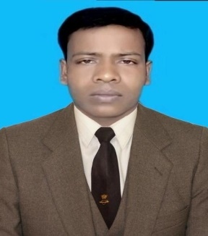
Career Objective:
To secure a position with a reputed organization with a stable environment that will lead to a lasting relationship. To obtain a position that will enable the use of my strong organizational skills, Microsoft expertise and ability to work well with new people new place.

Personal Information:

Name | : | Al - Belal
Father`s Name | : | Late. Nawshad Ali
Mother`s Name | : | Morjina Begum
Permanent Address | : | Village: Kathalbaria, Post: Premtali,  Upazila: Godagari, District: Rajshahi
Present Address | : | Village: Kathlabaria, Post: Premtali,  Upazila: Godagari, District: Rajshahi
Date of Birth | : | 16th December 1987
Gender | : | Male
Marital Status | : | Unmarried
Religion | : | Islam
Blood Group | : | AB⁺
National ID No  Birth Reg. No | :  : | 8113457705055  19878113457108097
Contact No : 01737566929
Nationality : Bangladeshi

Duties and Responsibilities

** Ability learn quickly and work under pressure.
** Work in a team environment and critical situations.
Language Skills:

** Medium verbal and written communication skills in English.
** Reading, Writing, Speaking competence is excellent in Bangla.

Strengths:
** Like to face new people and environment.
** Hard working habit, self-driven and change oriented.

Computer Skill:
** MS Word, MS Power Point, MS Excel, MS Access, Internet Browsing, E-mail.

Work Experience:
Name of organization | Duration |  | Designation
Name of organization | From | To | Designation
Sadik Construction | 01-01-2015 | 29-11-2017 | Supervisor
Responsibilities | Monitoring work, Maintains time and visitors, Perches necessary equipment for site, Write daily progress report and send to M D.

Educational Qualifications:
Masters of Social Work (MSS):
Name of Institution | : | Rajshahi College
Subject | : | Social Work
Board | : | National University
Passing Year | : | 2013
Result | : | 1st Class
Bachelor of Arts (BA pass) :
Name of Institution | : | Premtali Degree College
Subject | : | Arts
Board | : | National University
Passing Year | : | 2011
Result | : | 1st Division
Higher Secondary School Certificate (HSC) :
Name of Institution | : | Premtali Degree College
Subject | : | Science
Board | : | Rajshahi Education Board
Passing Year | : | 2006
Result | : | 2.40
Secondary School Certificate (SSC) :
Name of Institution | : | Premtali Sukbasia High School
Subject | : | Science
Board | : | Rajshahi Education Board
Passing Year | : | 2004
Result | : | 3.38

Reference:
Name | MD AL HELAL | MD ROBIUL ISLAM
Designation | Assistant Teacher | Project Manager
Institute | Premtali Josim Uddin Dakhil Madrasa. | 3Dots Ltd.
Address | Premtali, Godagari, Rajshahi. | House# 10, Road- 23/C, Gulshan-1, Dhaka.
Email | alhelalprem79@gmail.com | robi3010@gmail.com
Contact | +8801723901435 | +880 1710-003010
Relation | Brother | Job Related

Certification:
I certify that the information given is this CV is complete and accurate and this CV will be rejected if any wrong information is supplied with this.

Signature

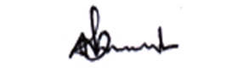
…………………….
(Al- Belal)

