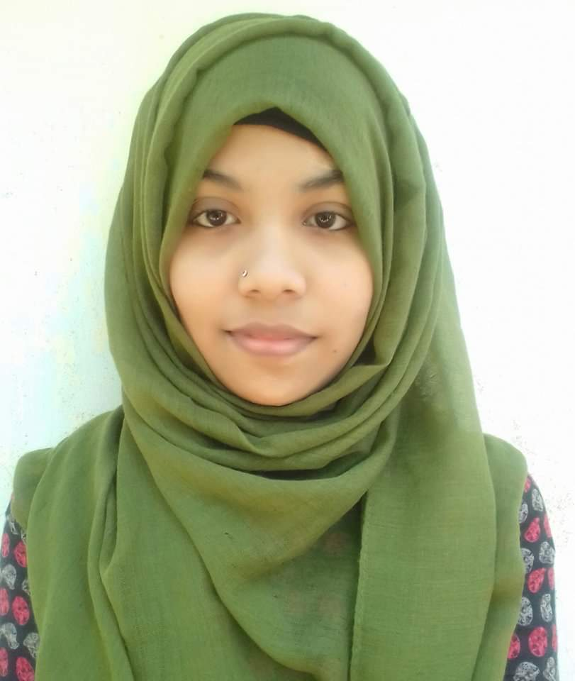
JUBI KHANOM
Address- Mogulpur, Fenchuganj, Sylhet
Mobile No- 01760079043

Email - noorjanahjubi@gmail.com

Professional profile
To find a challenging position to meet my competencies, capabilities, skills and education.
I am ambitious, self-motivated and always seeking new challenges having pride in my work and strive for the success; definitely an asset to an organization.

IT/Technical skills
- MS OFFICE  - MS Presentation  - Web Research | - Internet Research  - Video Editing  - Adobe Photoshop | - Image Editing  - Video content creator
Education and qualifications

- BBA ((Management), CGPA-3.10 (First Class) – Madan Mohan College, Sylhet

- HSC (Business Studies), GPA-5.00 – Fenchuganj Degree College– 2014

- SSC (Science), GPA-4.56 – Fariza Khatun Girls High School – 2012

Co-Curricular Activities

Founding Member
Nobo Utthan Social Organization, Sylhet
04/2016 – Present

The organization do social welfare and raise social mindfulness among the nation. I am with them from the very beginning. I am the current Vice-President and was also the former financial secretary of the organization.

Key responsibilities
- Building new relationships.
- Better cognitive function.
- Maintaining good emotional health.
- Acquire new skills.
- Increase Motivation.

Key achievements/projects
- Organized blood donation program.
- Organized Tree Plantation Program.
- Organized winter cloth distribution program.
- Organized Eid Cloth distribution program.
- Running a program named ‘Self-Employment’ among the underprivileged.

Self-Assessment
(1) Good at communication.
(2) Able to set priorities and routine tasks.
(3) Willing to learn and grow by accepting responsibilities.

