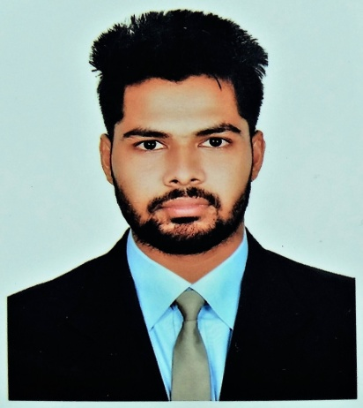
RESUME
OF
Md. Parvej Alam
E-mail: parvej9490@gmail.com
Mobile: +8801632639490
CAREER OBJECTIVES

Intend to work in challenging and competitive environment where strong sense of responsibility and commitment are where dignity of work provides job satisfaction and the place of work provides potential for learning, growing and achieving goals of the company.
ACADEMIC BACKGROUND

Secondary School Certificate (S.S.C/Dakhil):-
Institution | Bhogai Adarsha High School
Group | Science
Result (GPA) | 4.06
Year of Pass | 2013
Board | Comilla

Diploma in Engineering:-
Institution | Chandpur Gov’t Polytechnic Institute
Department | Computer Technology
Result (CGPA) | 3.32
Year Of Pass | 2017
Board | Bangladesh Technical Education Board
COMPUTER SKILLS

Hardware Engineering: Hardcore experience of assembling any computer / accessories, Network equipments, configures, and troubleshoots under any Windows Platform. Installing and configuring software.
Operating System: Windows 98, 2000, Windows XP, Windows 7.8.1 & 10, With Any Windows Boot.
Applications: Advanced Skills in MS Office, Word, Excel, PowerPoint, Access and Microsoft Outlook, Photoshop, Internet Browsing & Basic SEO Marketing….

INDUSTRIAL INFORMATION

Training Resum-1
Training Title : Three Month Industrial Attachment
Topic : Web Design & Development (PHP)
Institute : Crown IT & Software Development Ltd.
Location : Gulshan-1
Country : Bangladesh
Duration : 3 month
Year : 2017
Training Resum-2
Training Title : Three Month Training
Topic : Office Application In Computer Science and Technology
Institute : US Software Ltd
Location : Pranthopath
Country : Bangladesh
Duration : 3 month
Year : 2016

EXTRA CURRICULUM ACTIVITIES

1. Web Design & Development (PHP)
2. Wordpress Development
3. Advance Office Word Processing, Excel and PowerPoint & Good Typing……
PERSONAL ATTRIBUTES

* Able to maintain record of official documents and official corresponding.
* Able to input computer base data in systematic matter.
* Self-confidence to speak in public
CERTIFICATION

I certify that all information stated in this resume is true and complete to the best of my
Knowledge. I hereby authorize the respective concern to verify the information provided
in this resume."
SELF-ASSESSMENT

- Sincere and devoted to duties.
- Hardworking, Disciplined and Steady.
- Better learning Capability.
- Keen eyesight and better Sound analytical ability.
- Better ability to a take the duties, responsibilities and pressures
LANGUAGE PROFICIENCY

Bengali Fabulous Very Good Tremendous
English Medium Very Good Very Good
Language Speaking Reading Writing

PERSONAL INFORMATION

Name : Md. Parvej Alam
Father’s Name : Mobarak Ali
Mother’s Name : Sadiya Begum
Present Address : Lalbagh, Dhaka, Bangladesh
Permanent Address : Vill: Bhogai, P/O: Bhogai Bazar, P/S: Monhorgonj, District: Comilla.
Date of birth : 01/01/1994
Nationality : Bangladesh
National ID No. : 19971917470931040
Religion : Islam
Marital status : Single
Sex : Male
Height : 5 ft 5 inch
Weight : 60 Kg
Blood group : B _{(+ve)}

DECLARATION

I undersigned, hereby declare that I will be for responsible for any wrong information provided here.

Date …………………………………… Md. Parvej Alam

