RESUME
of
MD. RABIUL ISLAM
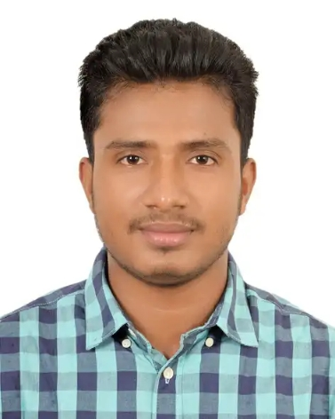
Mobile: 01757-644788
E-mail: rabiulislamrony18@gmail.com

Personal Information:
Father’s Name : Md.Ali Hosen Hawlader
Mother’s Name : Hiru Begum
Permanent Address : Vill:Dhola, P.O:Hanua,P.S:Bakerganj,Dist:Barisal
Present Address : Shahid Abdul Aziz Road, Basundhar R/A, Dhaka
Date of Birth : 01.01.1997
Nationality : Bangladeshi (By birth)
Marital Status : Unmarried
Religion : Islam (Sunni)

Educational Qualification:

Name of Exam | Institution | Department | Board | Passing Year | Result(GPA)
BSS | Kabai Union Islamia Degree College(100598) | Humanities | National university | 2nd year | Appeared
H.S.C | Kabai Union Islamia Degree College(100598) | Humanities | Barisal | 2018 | 2.75
Dakhil | Dhola Riaguddin Ideal Islamia Dakhil Madrasha | Humanities | Dhaka | 2014 | 4.31

JOB EXPERIENCE:
Position: Quality Controller
Employer: PQS Fabrics , Bashundhara R/A
Duration: 1st January 2017 to continue

Position: Marketing
Employer: MILI Accessories pvt. Co. ltd, Fakirapul, Dhaka
Duration: 2016 -2017

Position: Reception
Employer: Pacific Design Sourcing . Basundhara R/A , Dhaka
Duration: 2015 -2016

SPECIAL QUALIFICATION
- I have good fabrics knowledge
- Good Marketing experience.
- Creative, self-motivated and sincere.
- Good Communication interpersonal skill.
- Positive to work hard.
- Positive attitude.
- Quick decision making ability

COMPUTER SKILLS

- Computer Fundamental, Internet Browsing, E-mail Application.
- Good in MS Word, MS Excel, MS Power Point.

LANGUAGE PROFICIENCY

Language | Reading | Writing | Speaking | Listening
Bengali | High | High | High | High
English | High | Medium | LOW | Medium

Declaration:
I do here by declare that the above information provided by me and true, if any false found I people will be liable for that.

Signature
Md.Rabiul Islam
Date:__________

