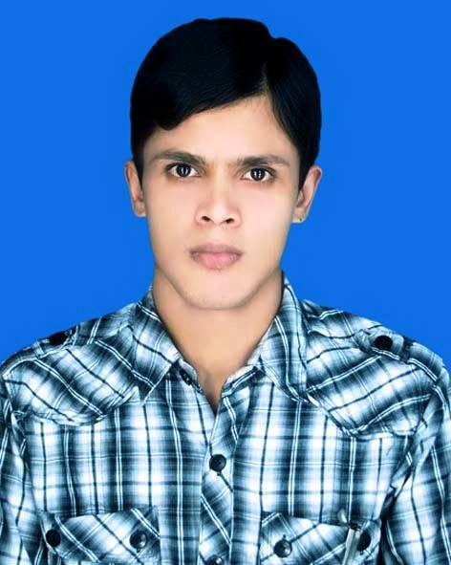
CURRICULUM VITAE
of Rafiz Khan

CONTACT:

Mobile :01725305593
Address : House #76,block A ,Tinset coloni ,Mirpur 13,
Kafrul, Dhaka 1216
Email: rafizkhan42@gmail.com

CAREER OBJECTIVE:
To develop a career in a renowned organization that provides structured career advancement and where I will get the opportunities to build up a career and be a part of the organization growth utilizing experiences, hard work and honesty.
ACADEMIC ACHIEVEMENTS:
Secondary School certificate (s.s.c)
Year of Passing : 2014
Result : 3.00 Out of 5.00
Institution : Bangladesh Open University
Computer skills
Micosoft office , Internet browsing
LANGUAGE SKILLS:
Good Command over Speaking and Writing Bangla and English.
HOBBIES & INTERESTS:
- Working in new & challenging environment & befriending people
- Traveling
- Reading book’s in leisure
- Web developing, Web researching etc.

PERSONAL INFORMATION:
Name : Rafiz Khan
Father’s Name : Tuku khan
Mother’s Name : Riba Begum
Present Address
House# 76 block A Tinset coloni,mirpur 13,Kafrul,Dhaka 1216
Permanent Address
Vill: Noyonpur P.S: joygram Thana : Naragati District : Narail
Date of Birth : 1st Jun 1994
Nationality : Bangladeshi by birth
Sex : Male
Religion : Islam
Marital Status : Unmarried
Blood Group : (O+) Positive
Date of birth certificate no : 19942692514289654
Contact No : 01725305593
E-Mail Address : rafizkhan42@gmail.com
Working Experience
- PrimeasiaUniversity 04 (Four) year office Support Service (OSS)
- Time of : 10 -06-2010 To 31-05-2014
- The Classic Medical Center 6 Month Time of 01-01-2019 To 01-06-2019
- Brothers Business point Sells & Manager Running..

Reference:

Date:.................. __________
Rafiz khan

