Razaul Karim Rahee 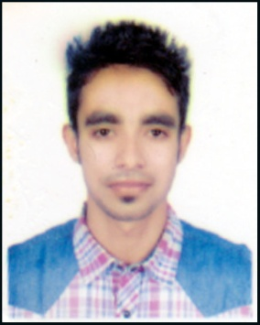
[Road no:43, House no:1,Block C,Shahajala Uposhohor,Sylhet]

[+8801621265026]•[raheerkr@gmail.com]

Career Objective

Willing To Be APart Of Organization That Will Provide AContinous Learning And ChallengingWorking Environment.An Oppurtinity to Weigh My Communication And Interpersonal Skills Extensively Use Previously Acquired Knowledge And and ToLearn New SkillsAnd Grow.

Achievements

1) Held a Perfect Attendance Record

2) Introduced company offers in different people.
3) Fulfil Company demand.
4) Established a good working relationship with customers.
5) Became a brand ambassador Of robi axiata limited.

Education and Training

[2013-2017] B.S.C (HONOURS), LEADING UNIVERSITY, SYLHET.

(Completed with B- on Computer Science & Engineering)

[2010 – 2012] H.S.C (HIGHER SECONDARYSCHOOL CERTIFICATE) [M.C COLLEGE, SYLHET]

5.00 Out of 5.00

[2008-2010] S.S.C (SECONDARY SCHOOL CERTIFICATE)

[SHAJALAL JAMIA ISLAMIA SCHOOL AND COLLEGE, SYLHET]
5.00 OUT OF 5.00
Employment

[2016– 2017] BP(Customer Servicing) [ROBI AXIATA LIMITED]

1) Customer Service.
2) Understanding cumtomer demand and knowledge.
3) providing internet facilities.
4) Brand Ambassador.
5) All Kinds Of Technical & Information Support.
[2017-2017] IT Instructor [Computer Source Ltd]

Skills

Technical:
1) Adobe Photoshop (Expert in Graphics Designing),Adobe In Design.
2) Google Analytics, Social Networks.
3) HTML & CSS.
4. MS Office, Excel, Android.
5. Basic Word press.
6.Expert In Installation & Setup Software properly.

Interpersonal:

1) Communication.
2) Effective Listening.
3) Decision Making Skills.
4) Team Player.
5) Appreciative
6) Coping with Pressure.
7) Leader Qualities.

Other:

1) Working in Fiverr as of a Web & Apps Ui Designer.
2) Working as a active member in leading university rotary club, leading university computer club.

Hobbies and interests

1) Playing any kinds Of Game.
2) Travelling Different Places for Entertainment And Gathering Knowledge.
3) Want To Help People And do Something for the orphan childrens.

References

Mahfuz Ahmed Chowdhury
Customer Service Officer
Robi AxiataLimited,Sylhet Branch.
+8801819550504
Rumel M S Pir
Senior Lecturer
Department Of Computer Science & Engineering
Leading University,Sylhet.
+8801825607080

