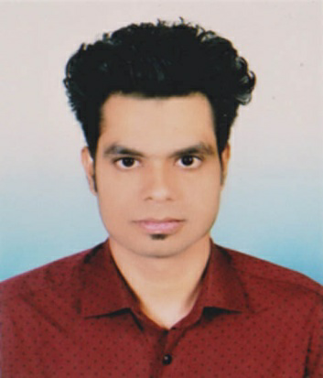
Resume of Rakib Hossen

Mailing address:
C/O: Abdul Sobahan Talukder House: Talukder Bari, Vill: Charkawa, Post: Charkawa, Upazila: Barishal Sadar, Dist: Barishal.
Cell: 01756275603
E-mail: falakrakib162@gmail.com

Career Objective:

Looking for hard and Challenging Job where I will have the scope to utilize my potentiality, adaptability and skill to do something innovate and from where I will be able to enhance my knowledge.

Interning Summary:

SL | Training Title | Name of The Institute | Location | Duration | Year
1 | Interning Course | SIBL Bank Ltd. | Barishal Branch | 03 Month | 2020

Academic Qualification:

Name of Examination | Field of Study | Institute/Department | Passing Year | CGPA | Board/ University
B.B.A | Major in Finance & Banking | Global University Bangladesh, Barishal. | 2020 | 3.14 (Out of 4.00) | Private University
H.S.C | Humanities | Barishal Model School  & College | 2015 | 2.67 (Out of 5.00) | Barisal Board
S.S.C | Humanities | Tofayel Ahmed Secondary School | 2013 | 3.13 (Out of 5.00) | Barisal Board

Personal Capabilities:

  - Energetic and capable to adopt in any type of environment.
  - Ability to work independently and as a member of any team.
  - Can work under pressure and enjoy working to meet the challenge.

Skill:

Computer Skills:
- Excel in MS office package (MS Word, MS Excel, MS Power Point)
- Having knowledge in Internet Browsing & E-mail

Language Skills:
- Expert in Reading, Writing, Speaking and Listening English and Bengali

Personal Information:

Name : Rakib Hossen
Father’s name : Ajijul Hoq
Mother’s name: Rashida Begum
Date of Birth : 12/05/1997
Religion : Islam
Marital status : Single
Blood group : O (+ve)
Sex : Male
Nationality : Bangladeshi
Permanent Address : Vill: Charkawa, Post:Charkawa, Upazila: Barishal Sadar, Dist: Barishal.

Name of Reference:

Nazrul Islam  Lecturer & Dept. Head  Business Administration  Global University Bangladesh  Email Id:nazruldu149@gmail.com  01719-987476 | Md. Manjur Morshed  Asst. Controller of Examination  Global University Bangladesh  Email Id: mmmorshed19@yahoo.com  01716091102

I hereby declare that the above cited information is true to the best of my knowledge and belief, if given a chance, I can prove myself.

Signature

Rakib hossen

