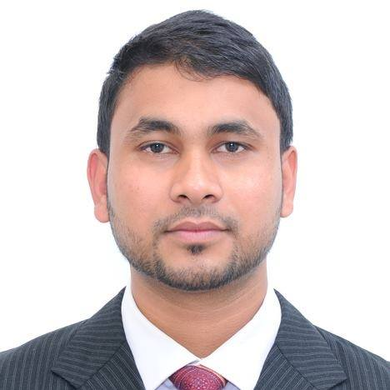
Ashraful Islam
A/51, Moin Vila, Jollarpar, Sylhet.
Mobile: +8801737-963893.
Email: programmerashraful@gmail.com

CAREER OBJECTIVE:
To work in a challenging environment, achieve skills in the respective filed and work for the simultaneous progressions of company and myself.

EDUCATIONAL QUALIFICATION:
Course Title | Institute Name | G.P.A/CG.P.A | Passing Year
BSC In CSE | Sylhet International University | ------------------ | Running
Diploma in Computer Engineering. (4 Year) | Islami bank Institute of Technology, Sylhet. | 3.40 Out of 4.00 | 2014
S.S.C | Sagornal High School | 3.81 Out of 5.00 | 2010

PROFESSIONAL CERTIFICATION:
Course Title | Institute Name | Course Duration
Computer Networking | Blooming Bird Information Technology | Six Month
Web Design And Development | TMSS-ICT | Six Month

Exprience:
Institute/Company | Post | Experience
Webnest IT | Web Programmer and Trainer | 2 Years

SKILLS:
Programming Skils: HTML, CSS, JAVASCRIPT, JQUERY, BOOTSTRAP 3, PHP, MYSQL, WORDPRESS THEME DEVELOPMENT & CUSTOMIZATION, CODEIGNITER.

PERSONAL INFORMATION:

Father’s Name: Hazi Abdul Lotif.

Mother’s Name: Rohima Khanom.

Date of Birth: 07/01/1992.

Religion: Islam

Blood Group: O-

Marital Status: Single.

Nationality: Bangladeshi.

Permanent address:
Holding Number: Abdul Lotif House, Sagornal, Juri, Moulvibazar.

LANGUAGE PROFICIENCY:

Name | Speaking | Writing | Reading
English | Medium | Medium | Good
Bangla | Good | Good | Good

HOBBIES:
I like to take challenge, Internet Browsing, Social working, Reading book and traveling etc.

REFERENCES:

Md. Masum Ahmed  Post: Owner  Company: Wbnest IT  Mobile: +8801723-388913 | Rahima Akther  Post: Lecturer  Institute: Islami Bank Institute of Technology, Sylhet  Mobile:+8801719-011982

