ss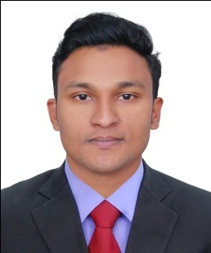
ALAMIN-01,CHARADIGHIRPAR,NAYASARAK,SYLHET.
EMAIL:sfshajan95@gmail.com PHONE:01786255050
SEEKING MANAGING POSITION AT A COMPANY
Organizing and planning essential and central services such as reception,leadership,maintainancemail ,as well as day to day running of the venue .Responsible for making sure that contracts,insurance requirements and safety standards are correctily complied with.
EDUCATION AND CERTIFICATIONS:
EXAM | RESULT | GROUP/SUBJECT | BOARD/UNIVERSITY | YEAR
SSC | 5.0 | SCIENCE | SYLHET | 2011
HSC | 4.30 | SCIENCE | SYLHET | 2013
BSc(Honours) | 3.14 | ZOOLOGY | NATIONAL | 2017

SELECTED SKILLS AND ACCOMPLISHMENT
- Managing time ,establish priorities and delegating effectively.
- Able to prepare budgets and cost estimates.
- In depth experience and understanding of the retail channel.
- Liasing with local authorities and regularotory bodies related issues.
- Excellent communication skills and ability to0 p[resent across all media.
- Can identify key opportunities and efficiencies for greater profitability.
- Providing the necessary coaching ,support and guidance to assist new staff.
- Ability to function in a fast-paced environment.

ADDITIONAL EXPERIENCE
- Have a modest command over English .
- IELTS band score 5.5
- Basic knowledge of computer (ms word,excel,powerpoint,photoshop,internet)

