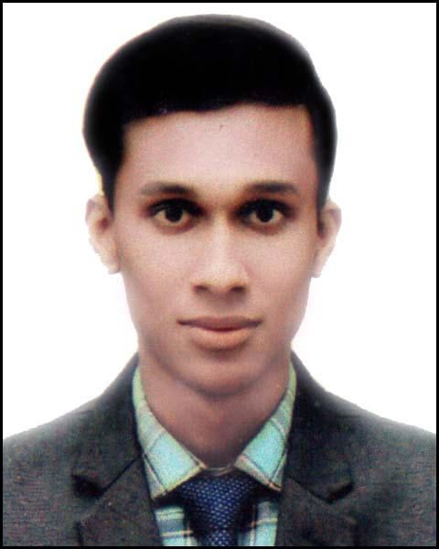

Resume
Of
Md. Oliur Rahman Riyad
Jalalabad Gas Quater , Sylhet
Contact: 01644146865
Email:oliurrahman2326@gmail.com

CAREER OBJECTIVE

To achieve high degree of professional excellence by putting continuous efforts and exerting knowledge
and skills which can eventually contributes to the achievement of personal and organizational goals.

ACADEMIC QUALIFICATIONS

Name Year
of Exam Group/ Major of passing Board/University GPA

Horner’s CSE Running Sylhet International University Running

H.S.C. Science 2016 Sylhet Board 3.08
S.S.C. Science 2014 Sylhet Board 4.44

EXTRA CURRICULAR ACTIVITIES

Worked as a YES of Transparency International Bangladesh (TIB).
Worked as a member of Volunteer of Bangladesh, JAAGO Foundation.
Bangladeshi Life Style photography and working with children.
Worked as Sunlight Battery Marketing Section 2years.
Worked as Pran Company Sr. 6month.
Worked at freelancing 4th year
PUBLICATION & TRAINING

Training Workshop On MS Word From (JUBOUNNYAION)

LANGUAGE PROFICIENCY
Bangla Reading, Writing & Speaking Excellent.
English Reading, Writing & Speaking Good.

INTERESTS
Traveling, Photography, Playing Cricket, Cycling, Music

COMPUTER SKILL
Having skills on Ms Word, Ms Excel, Ms Power Point & Internet

PERSONAL DETAILS

Father’s Name : Md. Abul Kashem
Mother’s Name : Halima Begum
Date of Birth : 23 August 1997
Present Address : Jalalabad Gas Quater sylhet
Permanent Address : vill-Biddabollob , P,O: Goraduba,
PS: Kandua , Dist: Natrokuna
Contact No : 01644146865
Marital Status : Unmarried.
Religion : Islam.
Nationality : Bangladeshi.

REFERENCES

Prof. Dr. Taher Billal Khalifa
Dean, school Of Business
Mobe:+8801711968256
Email: tkhalifa@mmetrrouni.edu.bd

I do hereby declare that particulars provided in the resume are true to the best of my knowledge and belief.

Md. Oliur Rahman Riyad
______________________

