`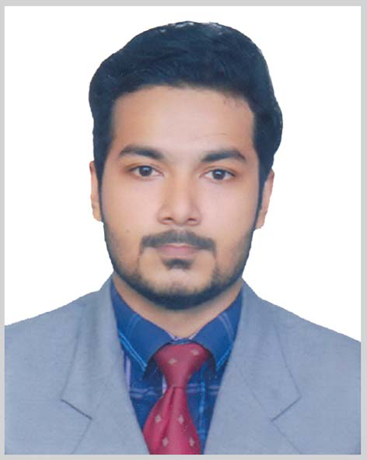

Rahul Dhar Roni

183/48/2, Road no: 12,
Norsingh tila, Bagbari,
Sylhet-3100, Bangladesh
rrdhar2018@gmail.com
+8801733735734

Profile Summary
Looking for hard and Challenging Job where I will have the scope to utilize my potentiality, adaptability and skill to do something innovating and from where I will be able to enhance my knowledge.

Field of Interest:
Accountant, Manager, Bank/Non-Bank financial institution, Commercial, Web development, Creative work

Academic Profile:

Bachelor of Business Administration(BBA in Accounting) | Major: Accounting
National University | Session: 2011-12
 | Passing year: 2015
 | CGPA 3.22 (on a scale of 4)
Higher Secondary Certificate (HSC) | Group: Business studies
Jalalabad Cantonment public School & College | Year: 2011
Sylhet Board | GPA 4.60 (on a scale of 5)
Secondary School Certificate (SSC) | Group: Science
M.C.Academy School & College | Year: 2009.  GPA:4.94(out of 5)

Golapgong ,Sylhet

Diploma in Food Preparation and cooking (cultural art) | Group: Cooking
City&Guilds(level-2),UCEP-BMET | Year: 2013
Sylhet | Merit

Training:
Under LICT Project, BCC. Graphic Design Year of training: 2016
Sylhet IT Academy
Web design and development
Year: 2018

Work experience : 6 months in Hotel metro international ,Sylhet
Resturent: 3 months.
Chef

Research Experience:

IT:
- Project name: A website for Own
Language : PHP,HTML, CSS,SASS,BOOTSTRAP
Database : MySql.

Co-Curricular Activities:

Web design, Drums Play, Good English typing skill ,Good knowledge of food processing (cooking),

Professional Skills:
Language Efficiency:
- Fluent in Oral and Written communication in Bangla and English.
Computer Proficiency:
- Skilled in using SPSS, SAS , HTML , CSS ,PHP
- Competent at the use of Microsoft offices packages: MS Word, MS Excel, MS Access, MS PowerPoint.

Personal Information:
Name: | Rahul dhar roni
Father's Name: | Hrishi kesh Dhar
Mother's Name: | Dipa Rani Deb
Permanent Address: | 183/48, Bagbari, Sylhet
Present Address: | 183/48, Bagbari, Sylhet
Date of Birth: | 24-Dec-1993
Religion: | Hindu
Nationality: | Bangladeshi
Marital Status:  Blood Group: | Not Married  0+

Credential References:

1.MritunjoyDharBhola
Advocate & Tax Consultant
Notary Public
Email: bholamd63@yahoo.co.uk
Contact No.: +8801674054007

2.Nupur Chandra Dhar
ACCA member
Financial manager in Metropolitan university ,Sylhet
Email: nupur@masihmuhith.com
Contact No.: +8801765523114

Declaration:

I, Rahul Dhar Roni, hereby declare that the information contained herein is true and correct to the best of my knowledge and belief.

Yours truly,
Rahul Dhar Roni
Date:

